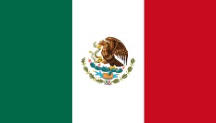
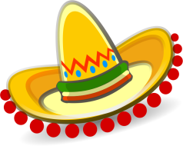
2nd Half Term Homework Project (in addition to weekly homework)

Plan and make at least two of the following:

- A piñata
- A Mexican hat
- A Poncho
- A Mexican food dish
- A sketch of Mexican scenery
- A Mexican menu
- A story set in Mexico
- A fact-file, poster leaflet about Mexico
- Research a Mexican song, dance or poem to perform
- Create a Day of the Dead mask or outfit

~ Due in Tuesday 17th December ~

