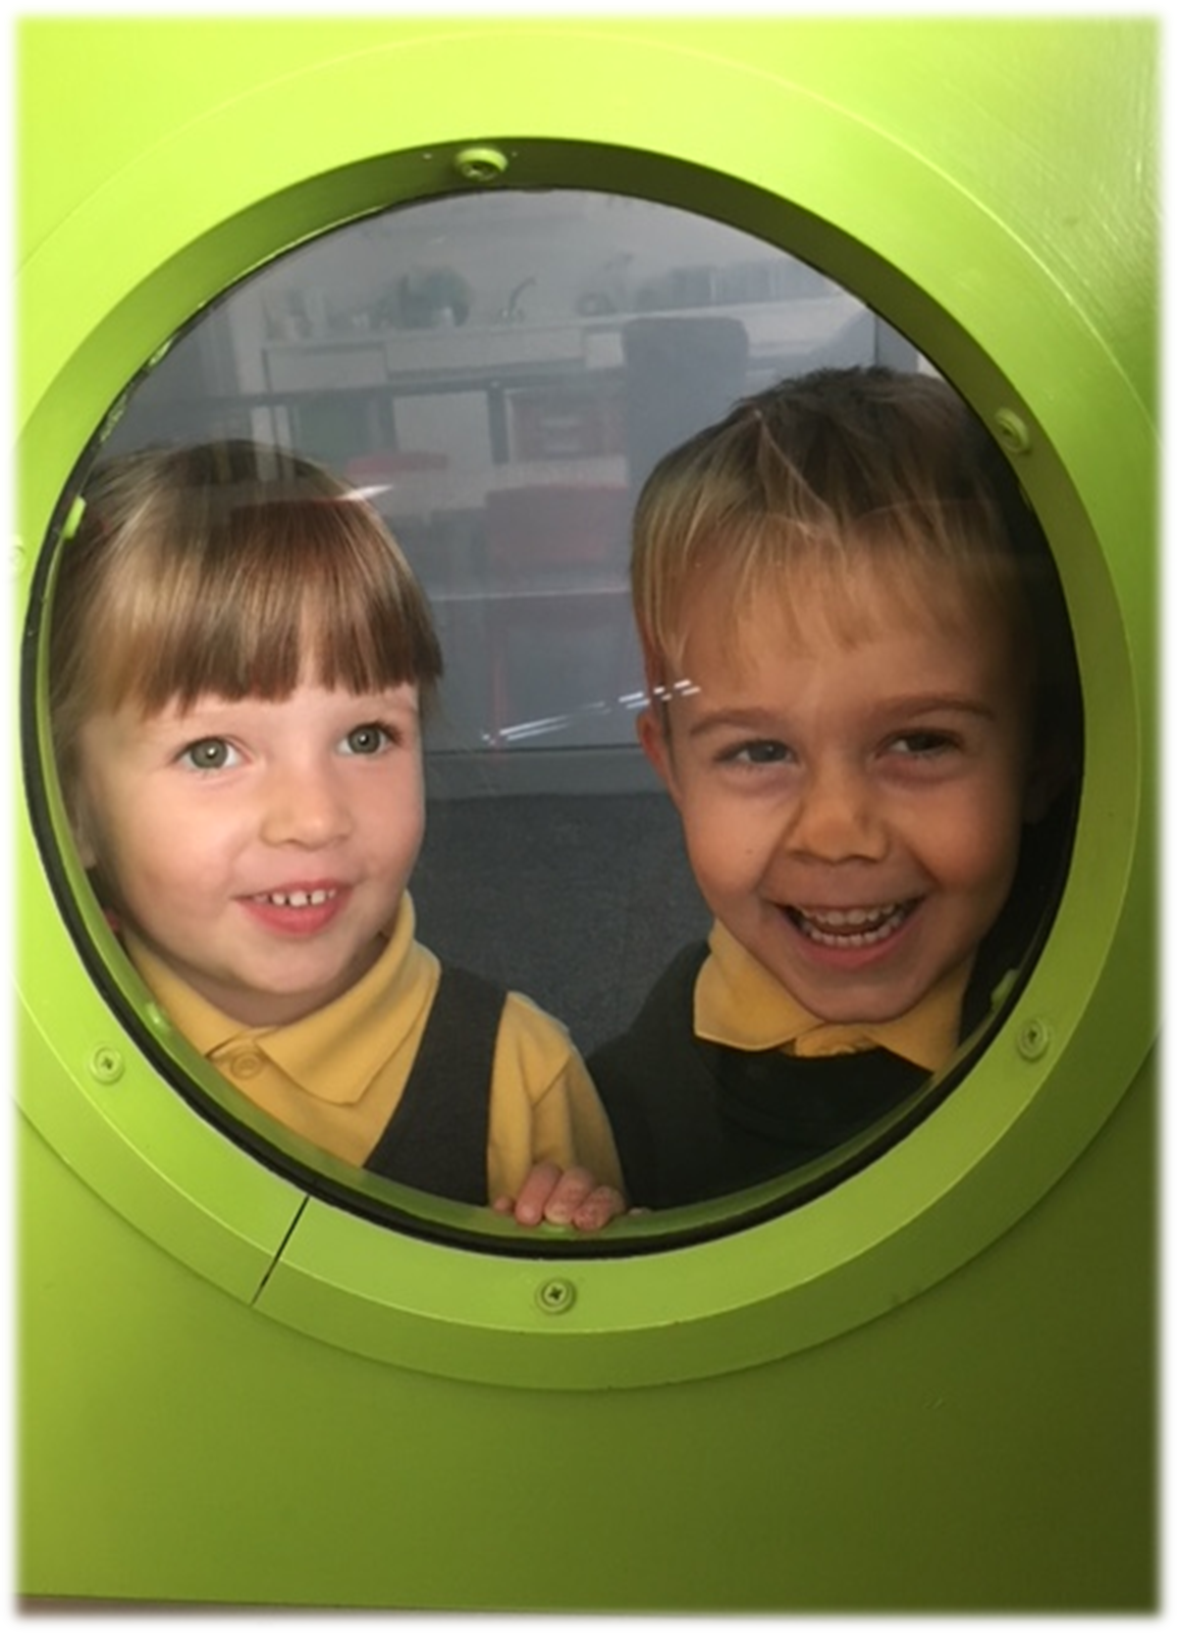
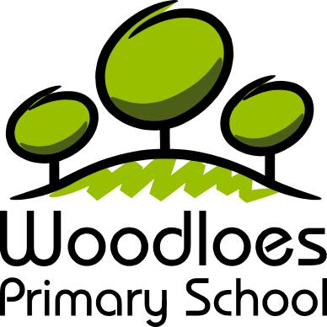
Prospectus 2019-2020

School Ethos
Loving Learning Together

Where children are:-
- Happy to learn
- Challenged and supported
- Prepared for the future
- Confident and successful
- Creative and positive

By:-
- Caring for each other
- Celebrating our differences
- Working in partnership with others
- Respecting our community
- Striving to be the best

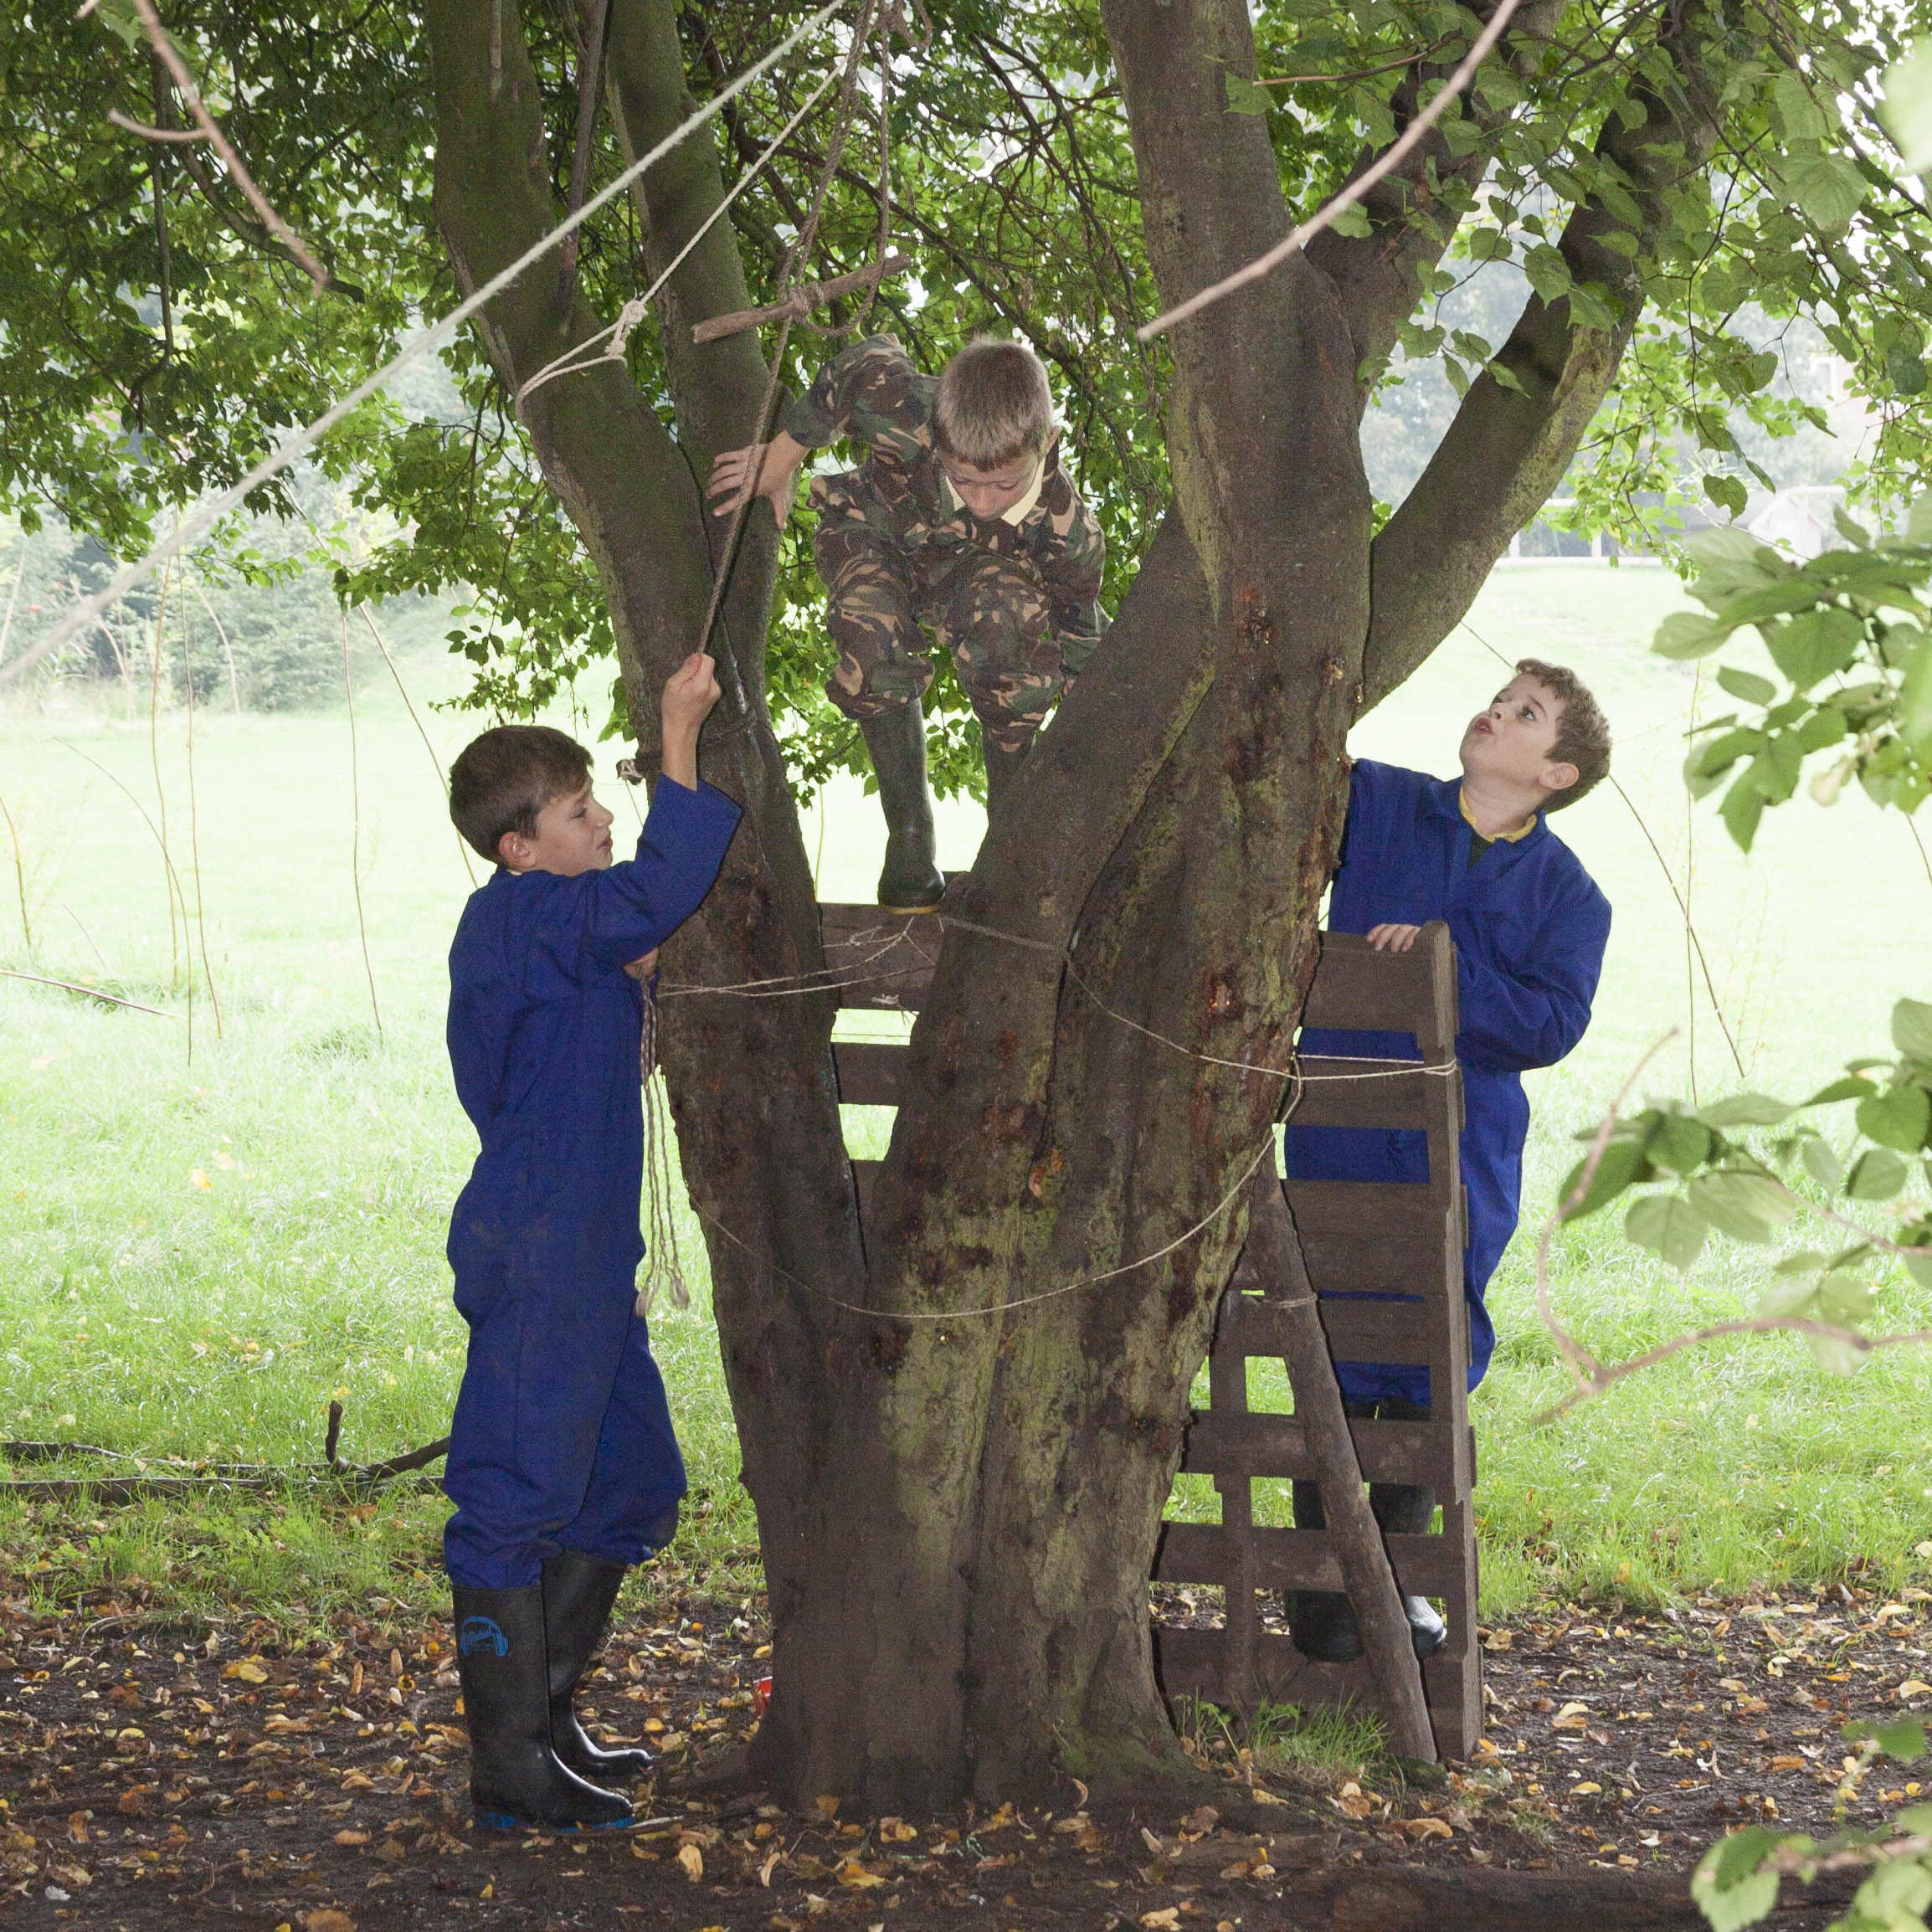

Welcome
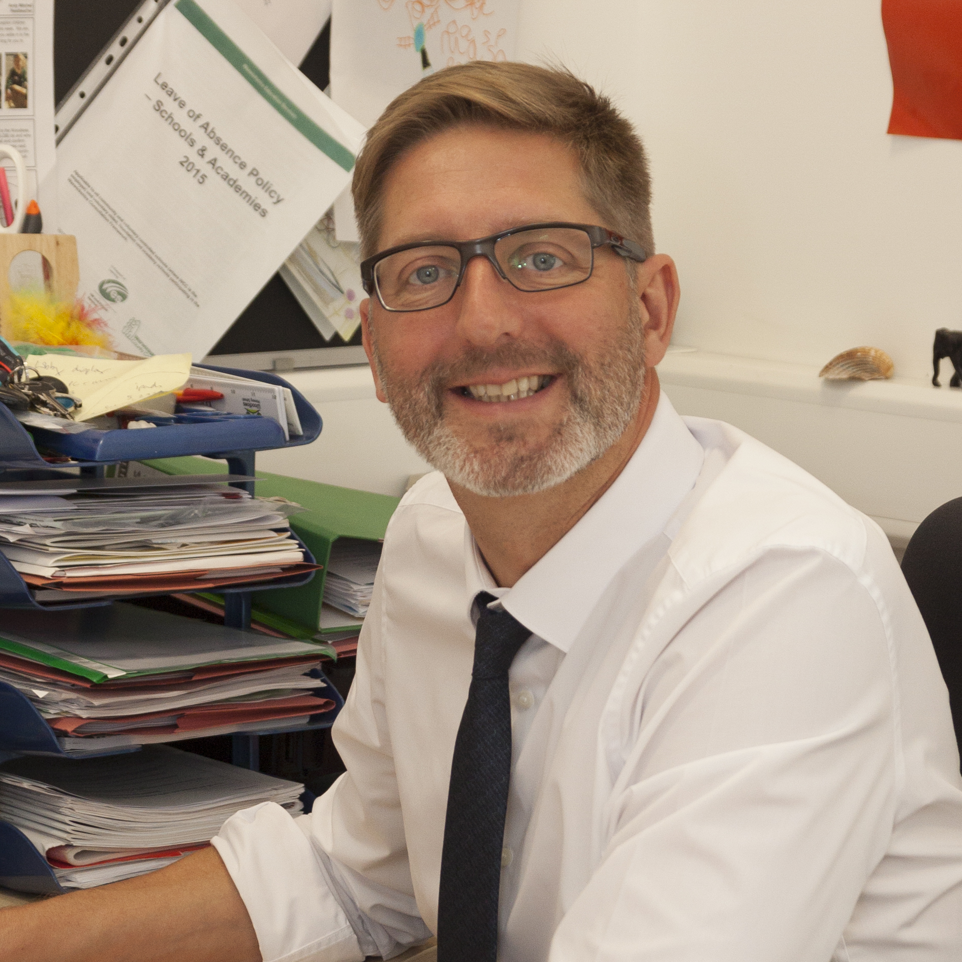

If your child is about to join our school, we would like to offer you a warm welcome and look forward to a long and productive partnership with you. We are committed to make your child’s time with us happy and successful in a stimulating environment where exciting fun- filled days are underpinned by academic rigour.

Our school is part of the Community Academies Trust and we play an active role in the central area to help to improve learning outcomes for all our pupils. We have talented staff who work closely with colleagues from other schools, dedicated to ensuring that the children develop the knowledge and skills they need to fulfil their potential.

We hope this pack contains the information you require to allow your child to settle quickly and make a confident start to their school careers. We pride ourselves on being a caring and responsive school that is focussed on personalising the children’s learning to reflect their interests and our local community.

We also welcome your involvement in your child’s education at Woodloes Primary School and offer many opportunities for this to occur through parent’s evenings, assemblies or a great range of events organised by our fantastic PTA. By working together, we will ensure that your child makes the very best possible start to their learning journey.

Andy Mitchell (Head Teacher)
(B. Ed (Honours) NPQH)

Head Teacher | Mr. Andy Mitchell
Deputy Head Teacher | Mrs Sian Stevens
Status | Community Primary School
Admission Number | 60
Capacity | 480
Age range | 3 – 11 years
Telephone | 01926 497491
Email | admin5207@welearn365.com
Address | Deansway, Woodloes Park, Warwick, CV34 5DF

Admission to School
The arrangements for admission to the Reception Year are provided to parents/carers in the Warwickshire County Council booklet ‘Primary Admission Arrangements’. A copy can be obtained from:
School Admissions Service
Saltisford Office Park
Ansell Way
Warwick
CV34 4UL
Tel: 01926 414143

The closing date for on-time applications is 15th January 2020. Parents/carers are encouraged to apply online at www.warwickshire.gov.uk/admissions. Alternatively, the School Admissions Service can be called on the number above. For families moving into the area the closing date for applications is 3rd February 2020. Parents/carers are able to make up to 6 school preferences and they will be allocated a school based on the published criteria included within the above-mentioned booklet.

Places for 2020 will be offered on 16th April 2020. Where parents would like their children to be admitted to the school, particularly if it is not the nearest appropriate school, they should be aware that there can be no guarantee that a place can be made available.

Wherever possible, preference will be met but there is a maximum number of children who can be admitted to the school (Standard Admission Number is currently 60 at Woodloes Primary School). Admission criteria in order of priority are:

- Children in the care of, or provided with accommodation by, a local authority and children who were looked after, but ceased to be so because they were adopted (or became subject to a child arrangements order or special guardianship order)
- Children living in the priority area given in the area booklet (Woodloes Estate) who have a brother or sister at the school at the time of admission
- Other children living in the priority area given in the area booklet
- Children from outside the priority area who have a brother or sister at the school at the time of admission
- Other children from outside the priority area.

In all cases, decisions are based on the distance between home and school by the shortest walking route, with priority going to those living nearest the school. This may apply equally to those living outside the authority boundaries

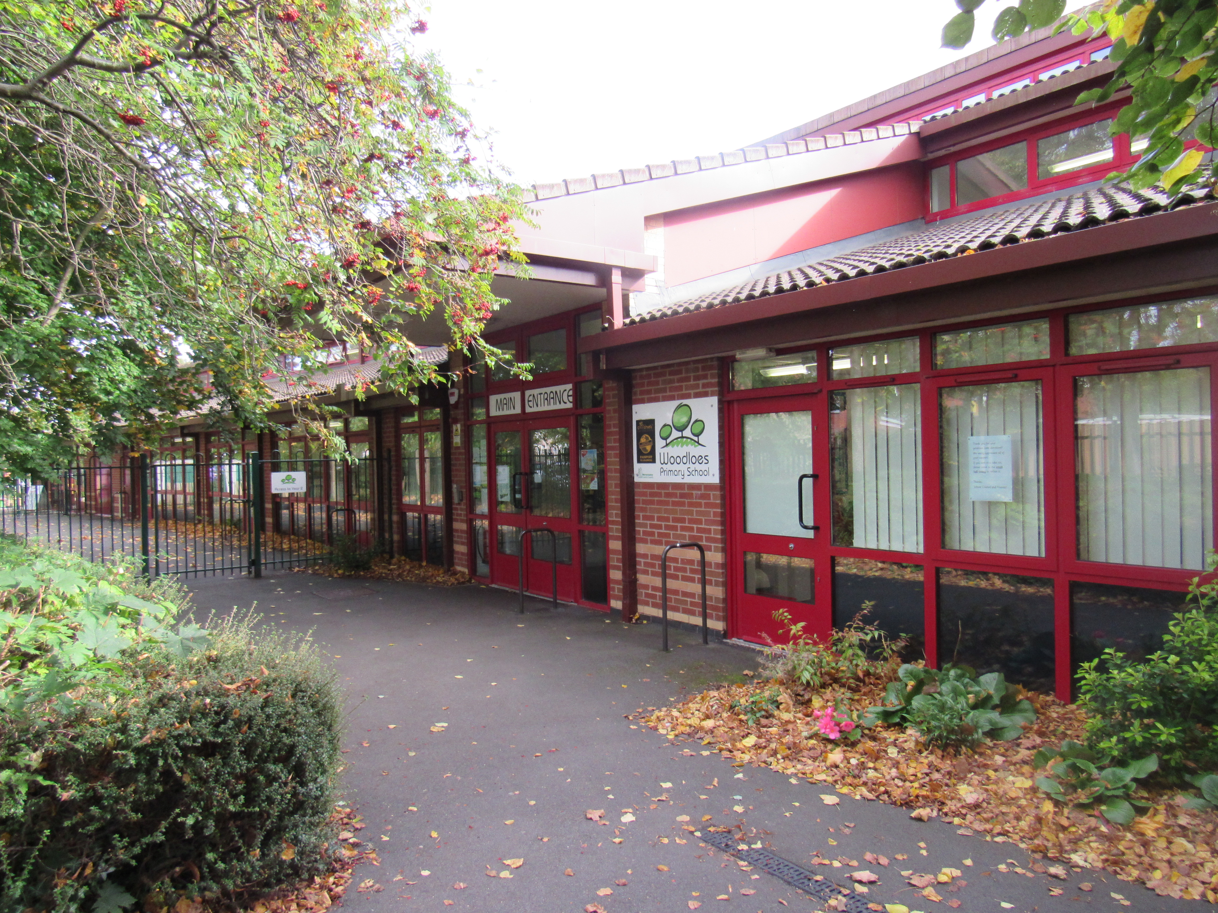

Appeals
If a child is refused admission to the school the parents have formal rights of appeal. Details may be obtained from the admission service.

About our School
Woodloes is a two-form entry primary school that opened in September 2009 following the amalgamation of the Junior and Infant Schools that had served the local community for many years. The construction and refurbishment of some of the existing accommodation provides fantastic facilities that also includes Saplings Pre-School, Oscar (out of hours childcare) and a Community Centre.
The extensive facilities that we have here provide the children with a safe, secure and stimulating environment in which to learn. Not only do we have wonderful classrooms and fantastic play facilities (we have our own castle with a slide) we have a Forest School area which enables the children to explore and use their imaginations in a safe outdoor woodland space which they love!
Our pre-school- Saplings- was commended in our recent Ofsted inspection and they work closely with our Reception classes as part of our Early Years Foundation Stage. This is an exciting, dynamic setting that offers the very best possible start for children as they enter primary education. If you have children approaching school age, then please make an appointment to come and see us in action.
Key Stage 1 (ages 5-7) build on the very successful start made in the early years. The children develop their skills in reading, writing and maths at an accelerated rate and learn how to apply these skills to solve problems in science and foundation subjects. They become confident, capable learners in Key Stage 1 and they share their love for learning in assemblies which our parents enjoy attending. We work hard to develop close links with home to support the children's learning with termly drop-in sessions to allow parents to see for themselves their children's work and progress.
In Key Stage 2 (ages 7-11) the children become more independent in their learning and really broaden their skills and experiences. Year 3 and 4 is the middle phase and there is a huge breadth and balance in their curriculum entitlement. Year 5 and 6 is the upper phase and the pace and complexity of the children's learning is sophisticated and extensive. We have the very highest expectations of our children as learners at Woodloes and everyone works to the best of their ability to achieve their potential.
Ofsted were very complimentary about our school and the high standards that have been achieved and a link to their most recent report (March 2019) is available from the HOME page of our website. The school has achieved and maintains the very highest standards and we are always determined to ensure that every child has the opportunity and support to achieve their very best.
One of the main characteristics of our school is not just what we do but how we do it. Woodloes is a fabulously caring environment and we go about our business with a sense of fun, excitement and pride in our achievements. We work hard to build effective partnerships with others and believe strongly that we should share ideas and resources to build a stronger more effective education system to improve the life chances for every child.
We believe in sharing ideas, expertise and resources with others and had the opportunity to work closely with Warwickshire County Council and developers to successfully open the new Heathcote Primary School. In 2015 we chose to join the Community Academies Trust to provide further opportunities for improvement by working in partnership with outstanding providers.
If you are a new parent, thinking about sending your children to our school then we would encourage you to talk to existing parents and families about their experiences with us or make an appointment to visit the school. Our older children like to show prospective parents around their school which they do with an enthusiasm and honesty that visitors find helpful and reassuring.
If you have any questions about our philosophy or vision or any aspects of our provision, then please make contact with the school or arrange to come and see us in action.

School Uniform
School uniform plays an important role in reflecting the ethos of the school and helps develop a sense of pride in the children.


The school colours are green, yellow and grey. We encourage all children to wear the school uniform, which is intended to be both simple and practical allowing all pupils to take part in the full range of activities. The uniform is available from Woodloes Supermarket on the Woodloes estate, or on-line from www.yourschooluniform.com.
Boys | Girls
Yellow Polo Shirt | Yellow Polo Shirt
Dark Green Sweatshirt | Dark Green Sweatshirt or Cardigan
Grey Trousers | Grey Pinafore Dress or Skirt
Grey Shorts | Yellow or Green Check Dress
Grey Socks | Grey Socks or Tights
Flat Black Shoes | Flat Black Shoes
PE Kit
Black Shorts
White T Shirt
Plimsolls or Trainers (Trainers required for KS2 children)
Jogging bottoms (for cold weather)
Suitable strong Kit bag

Various extracurricular team sports are available at the school. If a child becomes involved in team sport with specific kit requirements you will be advised in due course.

It is essential that all items are labelled with your child’s name.

Our School Day

Reception and Key Stage 1 |  |  | Key Stage 2
Registration | 8.55 am |  | Registration | 8.55 am
Session 1 | 9.00 am - 10.30 am |  | Session 1 | 9.00 am - 10.30 am
Break | 10.30 am – 10.45 am |  | Break | 10.30 am – 10.45 am
Session 2 | 10.50 am – 12.00pm |  | Session 2 | 10.50 am – 12.00pm
Lunch | 12.00pm - 1.10 pm |  | Lunch | 12.00pm - 1.10 pm
Session 3 | 1.10 pm – 2.15 pm |  | Session 3 | 1.10 pm – 3.20 pm
Break | 2.15 pm – 2.30 pm |  | Session 3 | 1.10 pm – 3.20 pm
Session 4 | 2.30 pm – 3.15 pm |  | Session 3 | 1.10 pm – 3.20 pm

Teaching time occupies 4.5 hours per day in KS1 and 4 hours 50 minutes in KS2 with supervised breaks, assemblies and registration making up the 22.5 total hours per week (KS1) and 24 hours 10 minutes (KS2).

Children should arrive for 8.45 am, when teaching staff are available to supervise them. Children returning home for lunch should not return before 1.00 pm unless they are taking part in any school activity.

If a child is not collected on time at the end of the day and we have not received any notification within 15 minutes, we will presume that an emergency has arisen, and will instigate our procedure for uncollected children. A full copy of this procedure is available at the school office.

Attendance
Attendance and punctuality are critical factors not only to your child’s education but also to the success of the school and therefore other children. Please ring the school before 9.30 am on the first day of the child’s absence. Children also require an appointment card from the dentist or doctor when undergoing sustained treatment. It is now school policy to ring parents if we do not have prior notification of appointments or parents have not contacted the school. This is to ensure the safety of all of our children.

Holidays in Term Time
A child’s education suffers when the continuity of their school work is disrupted by holidays taken during term time. It is a legal requirement of parents/carers to ensure that their children are in school for 190 days per year. We are obliged to consistently apply the criteria for authorised absences set out by the Local Authority. Application forms for a leave of absence are available at the school office.

Snow Days
In the event of the school having to close due to bad weather, we will notify Warwickshire County Council who will post the information within 20 minutes on their website (www.warwickshire.gov.uk/schoolclosures). A free text and email alert service is also available from the Warwickshire County Council website.

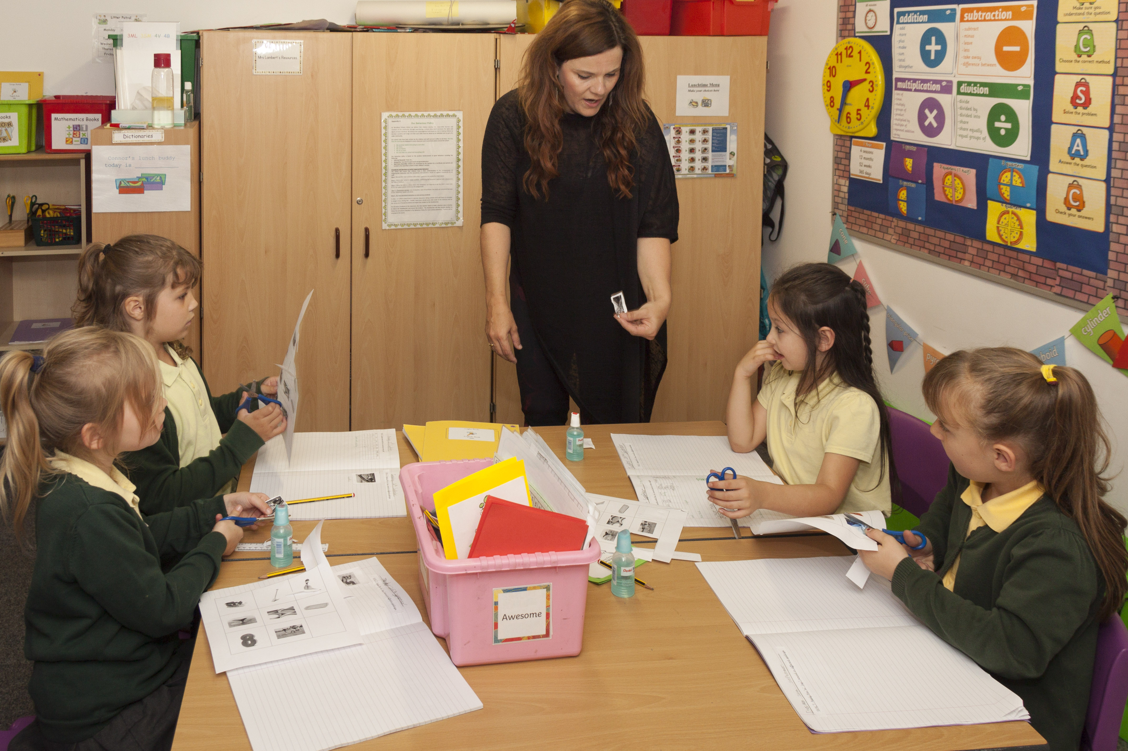
The Curriculum
At Woodloes Primary School our curriculum recognizes that all children are different - they have different interests and are stimulated by different things. We have developed exciting topics and themes that are highly engaging for the children and reflect the locality in which they live. The whole curriculum is directed towards raising the level of children's achievements by personalizing their learning experiences.

Our shared vision for the school ‘Loving Learning Together’ informs the way that we deliver the curriculum. The key skills underpin each of the different National Curriculum subjects. We believe that the development of these key skills promotes positive attitudes to develop lifelong learning.

Early Years Foundation Stage
Children are born ready, able and eager to learn. They actively reach out to interact with other people and in the world around them. Development is not an automatic process, however. It depends on each unique child having opportunities to interact in positive relationships and enabling environments
Our curriculum planning follows the guidance from the Development Matters in the Early Years Foundation Stage Curriculum. It underpins future learning by supporting and promoting each child's development in both prime and specific areas.
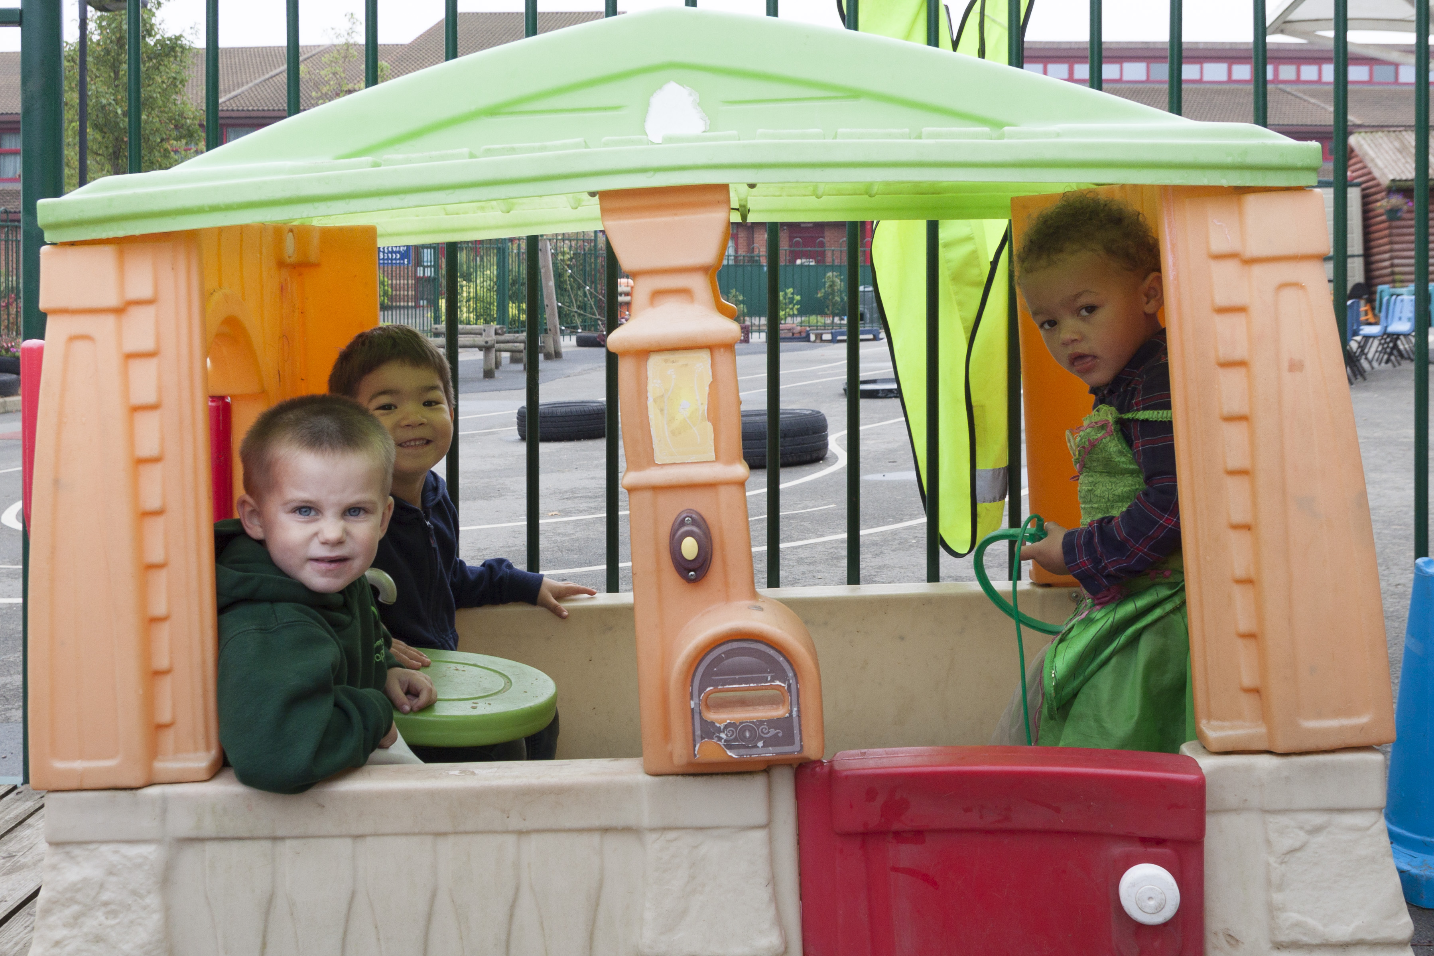
The prime areas begin to develop quickly in response to relationships and experiences and run through and support learning in all other areas. The prime areas continue to be fundamental throughout the EYFS.
- Personal, Social and Emotional Development
- Communication and Language
- Physical development
The specific areas include essential skills and knowledge. They grow out of the prime areas and provide important contexts for learning.
- Literacy
- Mathematics
- Understanding the World
- Expressive Arts and Design
The characteristics of effective learning are how children learn through engaging with other people and their environment.
- Playing and exploring
- Active learning
- Creating and thinking critically
These underpin learning and development across all areas and support the child to remain an effective and motivated learner.

Key Stage 1 and Key Stage 2

Our curriculum puts into practice the requirements of the new National Curriculum, the Local Authority and the ethos of the Community Academies Trust. The curriculum can be split into the following three areas:
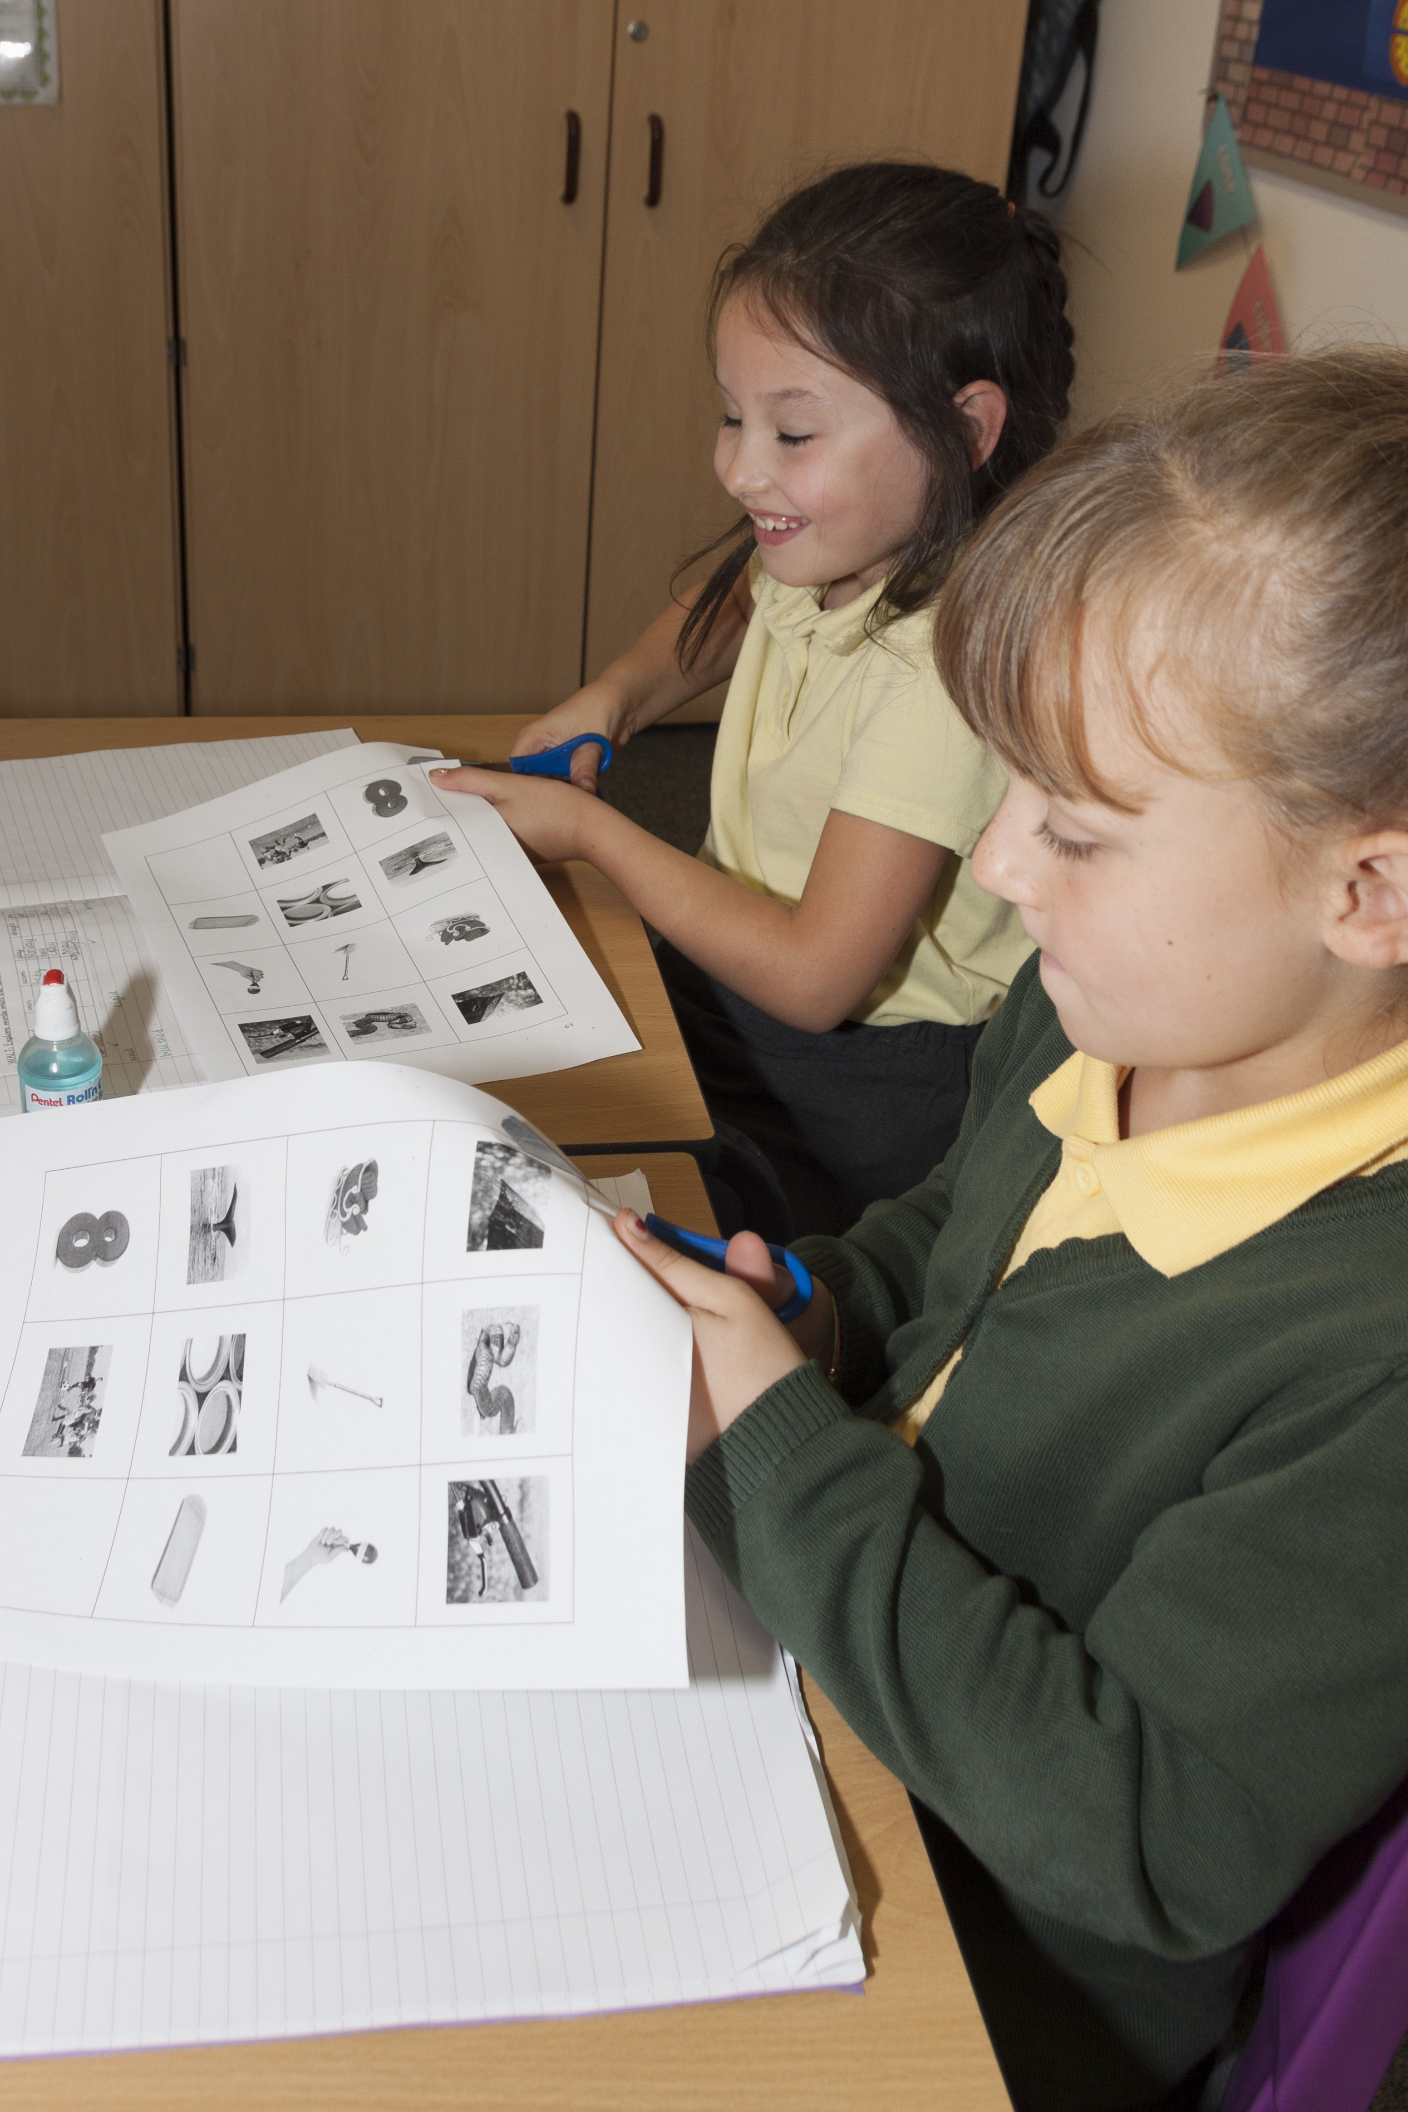
Core Subjects
- English
- Mathematics
- Science
- Computing

Foundation Subjects
- Geography
- History
- Music
- Art
- Technology
- Religious Education (RE)
- Physical Education (PE)
- Modern Foreign Languages (MFL)
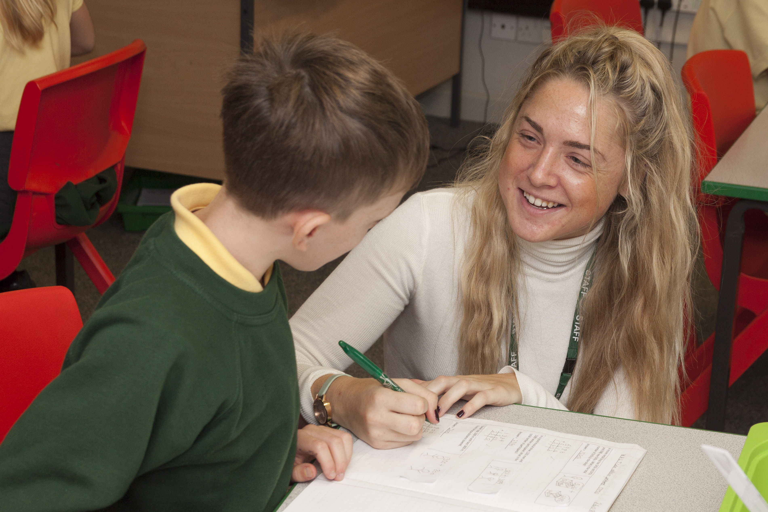
Personal, Moral and Spiritual Education
- Collective Worship
- Personal Social and Health Education (PSHE)
- Citizenship

While the different curriculum areas are presented as separate National Curriculum subjects, they are normally taught in a cross-curricular way in KS1 (Years 1 - 2) through topic work. In KS2 (Years 3 – 6) the foundation subjects are generally taught using a topic-based approach
with a focus on Mathematics and English.

Religious Education and Assemblies
The school teaches Religious Education following the Warwickshire Agreed Syllabus. Planned work in RE links where possible to other areas of the curriculum and seeks to develop pupils` knowledge, understanding and awareness of the principal religions represented in our country today. Our aim is to promote a respect for the beliefs of others and to provide opportunities for pupils to explore and reflect upon their own beliefs and commitments.

Our assemblies make a significant contribution to the social, moral, spiritual and cultural development of the children and promote British Values. Parents and friends are invited to our Achievement Assemblies when we all share in the children's success, both in and out of school and so foster their sense of self-esteem and a pride in their own achievements and those of others. We like all children to take part in assemblies, but if parents wish to withdraw their child from religious activities they should discuss alternative arrangements with the teacher.

Sex and Relationships Education

It is important that parents know which aspects of SRE their children are encountering in school and when specific knowledge is being taught as a planned part of a class topic. Parents will be informed so that they may be prepared for any questions or concerns which children may express. Parents have a right to withdraw their child from sex education lessons if they so wish but relationships education is compulsory from September 2020. If parents have any concerns about the proposed content of these lessons they would be asked to voluntarily state their objections so that the school could be sure that no misunderstanding had occurred and could be aware of parental attitudes.

A full copy of our PSHE/Sex and Relationship Education Policy is available at the school office.

Special Educational Needs and Disabilities



We are committed to providing an appropriate and high-quality education to all the children living in our local area. We believe that all children, including those identified as having special educational needs, have a common entitlement to a broad and balanced academic and social curriculum, which is accessible to them and to be fully included in all aspects of school life.

We recognise that pupils learn at different rates and that there are many factors affecting achievement, including ability, emotional state, age and maturity. We believe that many pupils, at some time in their school career, may experience difficulties which affect their learning and we recognise that these may be long or short term.

Our Special Needs and Disabilities Coordinator (SENDCo), working with both the staff and parents/carers, helps to identify any needs at the earliest opportunity and provide teaching and learning contexts which enable every child to achieve to his or her full potential.

A full copy of our Special Educational Needs and Disabilities Policy is available at the school office upon request.

Most Able / Higher Achieving children
Teachers identify most able/high achieving children as part of an ongoing process of monitoring and assessment. These are children who confidently attain targets for their year group in a range of subjects and who are subsequently able to work in greater depth to demonstrate their level of understanding and achievement.

As with other groups of learners, the attainment of higher achieving children is monitored regularly throughout the year.

Every pupil – whatever their level of attainment - should have the right personalised support to achieve their very best. For higher achieving pupils, this means stretch and challenge in every classroom.

Providing for higher achieving pupils in our school is a question of equality - as with all other pupils, they have a right to an education that is suited to their particular interests and abilities. They need to be presented with work that challenges, stretches and excites them on a daily basis, in an environment that promotes and celebrates excellence.

Pupils’ Progress
.
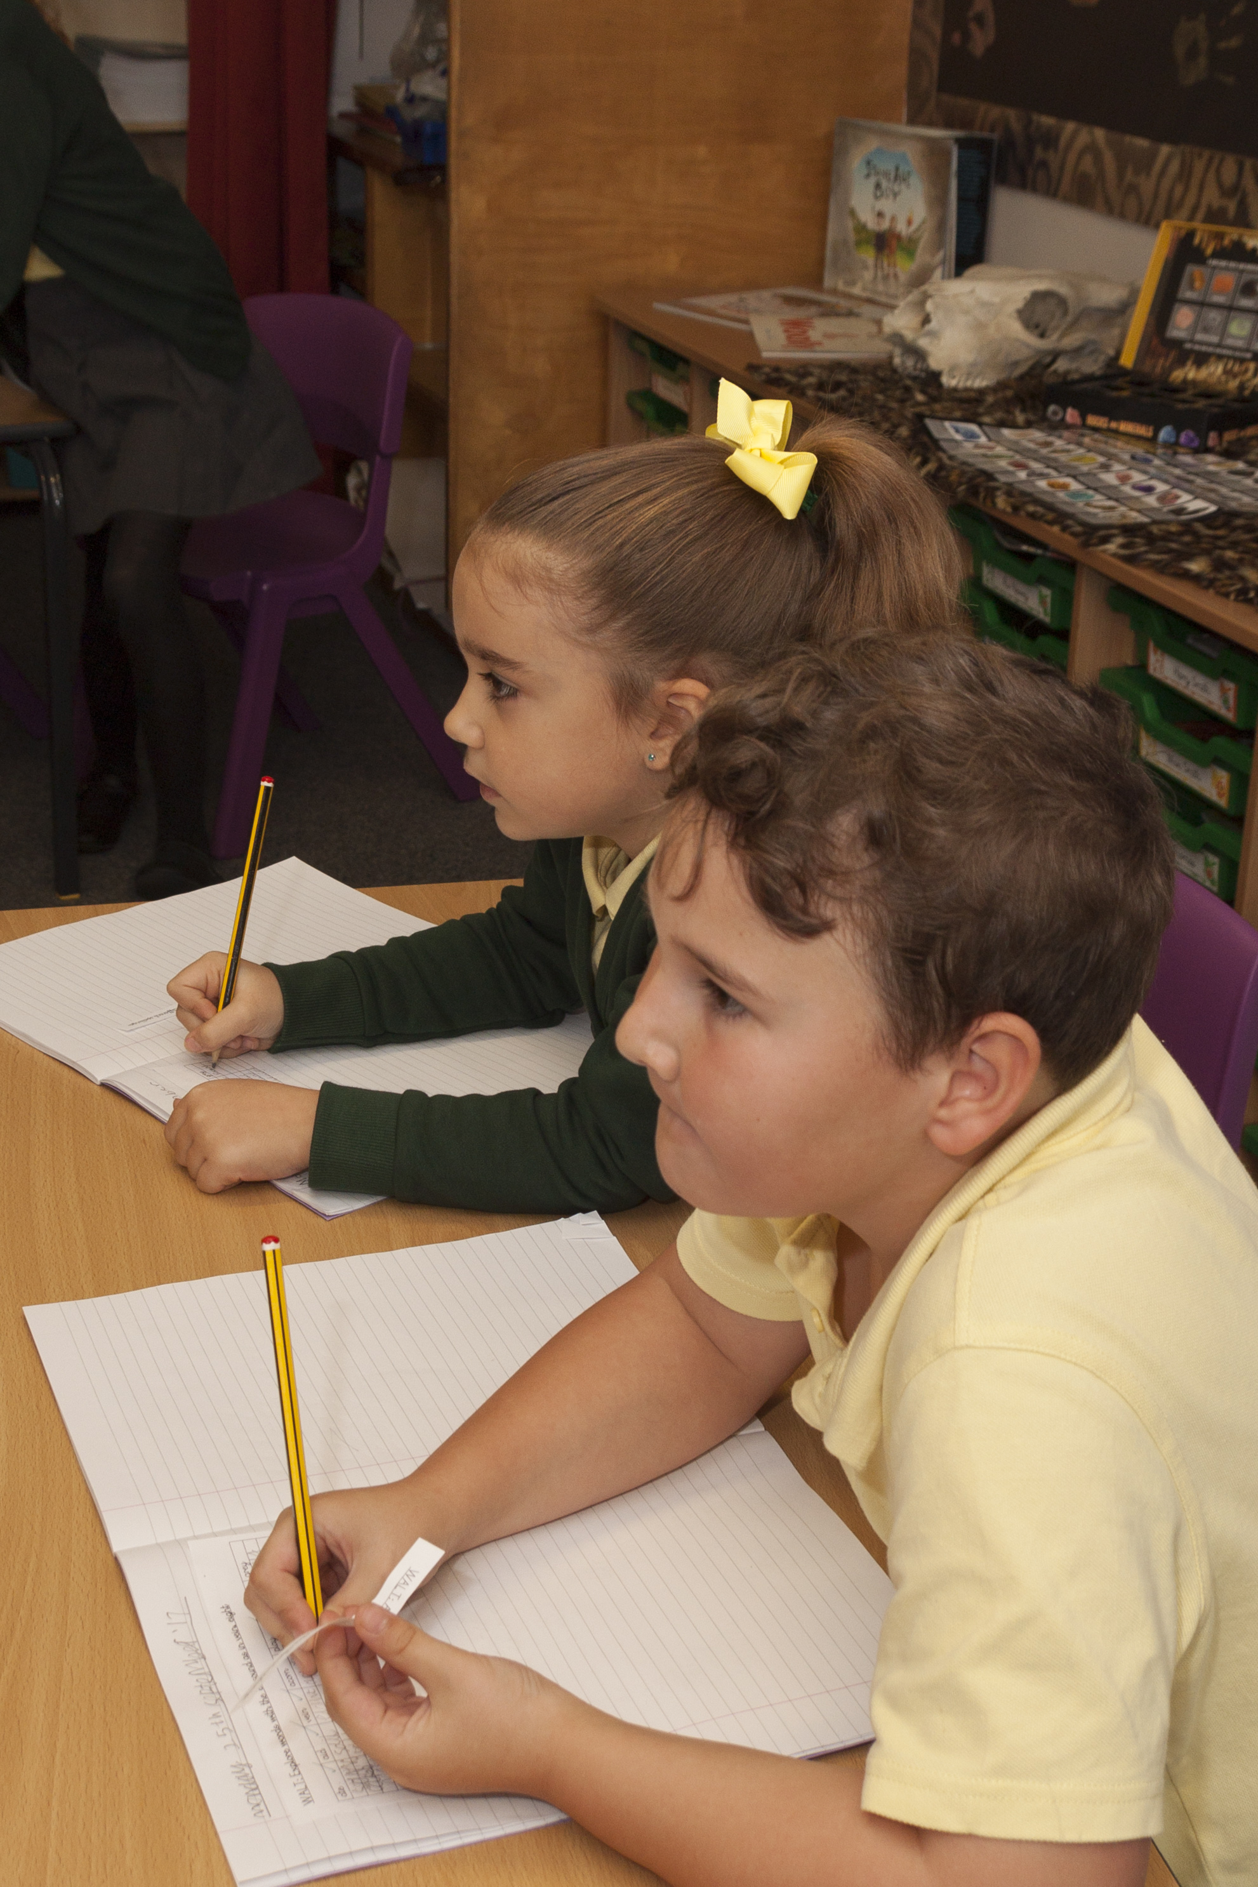
Children are assessed at each stage of their learning both formally and informally. Teachers need to understand children’s areas of strength and identify any gaps in their understanding to be able to teach high quality engaging lessons that meet the needs of all learners

There have been significant changes to the way children are assessed that came into effect in September 2015 and you will become increasingly familiar with this new methodology which is known as “Assessment without levels”. Through teacher assessments and moderation within school and with other Warwickshire schools, we are able to ensure consistency of standards throughout the school and against national standards. In addition, there are statutory assessments for Reception (Foundation Stage Profile), Year 1 phonics test, Year 2 (Key Stage 1 Standard Assessment tasks or SATs) and Year 6 (Key Stage 2 Standard Assessment tasks or SATs).

Parents are invited to consultation meetings and the results of tests and teacher assessments are discussed and reported on to ensure you understand how well your child is doing.

Behaviour and Discipline
We value our reputation as a happy and caring school. Ofsted have always commented very favourably on pupil behaviour and standards and our children are recognised in the local community as being polite, respectful and well-mannered individuals. This is a well-ordered and disciplined school; our rules are simply based on kindness and respect to ensure the safety and well-being of the school community.

We encourage our children to develop self-discipline and accept responsibility for their own actions. British Values are known and understood by the children and these are promoted through assemblies, ongoing discussions and in the actions taken by our School Council. Discipline is a shared responsibility between pupils, parents and teachers and the involvement and support of all three elements is vital in the development of self-discipline. This is reflected in our behaviour policy.

On very rare occasions when behaviour is unacceptable, we will impose sanctions that may include loss of privileges or free time, but these will always be reasonable and proportionate. We believe that parental support ensures that our few rules are effective and enable our children to accept responsibility for their own actions. However, serious or persistent behaviours could result in a fixed-term or permanent exclusion.

Bullying is forbidden, and all reported incidents are investigated, recorded and monitored. Any incidents of bullying and actions taken are reported to the governing body to ensure the school remain vigilant in keeping the children safe.

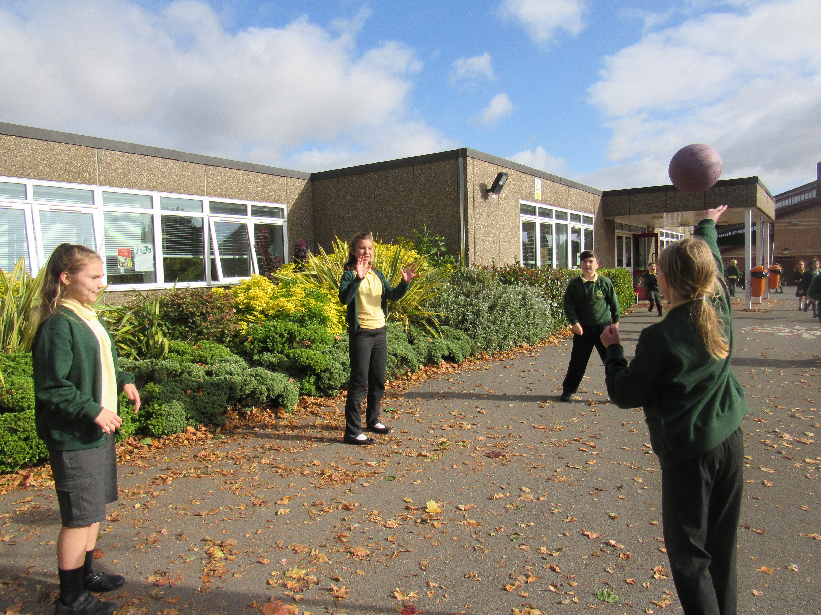

Safeguarding and Child Protection

Keeping your children safe is of paramount importance to us. We maintain a safe environment for all of our children and staff by being vigilant and very aware of any potential risks.

We apply safer recruitment policies when we appoint any staff to work with your children and ensure that all staff are kept up-to-date on safeguarding procedures to create a positive, well-informed and safe environment for your children.

We have robust procedures in place that meet statutory guidelines, and these are regularly monitored and checked by our governing body. We also work very effectively with families and other agencies to ensure that the appropriate actions are taken to address any concerns about pupil safety and their wellbeing. We work hard to create a ‘culture of vigilance’ and expect everyone at school to maintain this ethos and practise.

In everything we do, we are committed to safeguarding and promoting the welfare of children and young people and we expect all staff, parents and volunteers to share this commitment.

We are a Healthy School
Many factors contribute to be a healthy school including the following:

Lunchtime Meals
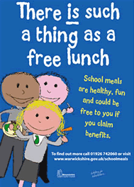
Our good quality dinners are supplied by Educaterers and are cooked freshly each day in our kitchen. We operate a self-service system where children select their meal choice at the beginning of the school day and are given this at lunchtime. This system encourages children to develop good eating and social habits.
Children also have the option of bringing packed lunches. We encourage parents to make these as healthy as possible and share good ideas with each other. We do not allow sweets or fizzy drinks.
Picture placeholder

Healthy school logo.
Do we have this status?
Menus can be viewed at www.warwickshire.gov.uk/schoolmeals.

Payment for school meals
Payment for school meals are made online via Parent Pay and must be made in advance. Information about Free Meals is available in the office or at www.warwickshire.gov.uk/freeschoolmeals. All enquiries are treated in strict confidence.

Universal Infant Free School Meals
Currently, all children in Reception and KS1 receive free school meals but we would still encourage you to apply for free school meals if you are eligible, as this can bring additional funding into the school through the Pupil Premium Grant. School budgets are desperately short of funding, so it is vital to secure as much income as possible. Please check with the school office if you think this might apply to you.

Milk
Milk is available free for all children who are under 5. For all other children there is a charge. Everyone must complete an order form to be sent to the dairy if you wish your child to receive milk in school (even under 5s). Milk is delivered regularly and kept in a fridge.


Keeping children well hydrated

Children have access throughout the day to water. They can bring in their own labelled bottles or, for a small charge, bottles can be purchased from the school office. Children can refill them as required.

School Fruit and Vegetable Scheme
As part of the National Fruit Scheme each child in Foundation Stage and Key Stage 1 is provided with a daily piece of fruit or vegetables.

Extra Curricular Activities

The school provides a variety of extra curricular activities during lunchtime and after school. Clubs vary from year to year. Some examples of what we offer are:

Lunchtime |  | After School
Street/Pop Dance |  | Multi-sports
Choir |  | Art & Craft
Judo |  | Netball
Table Tennis |  | Football
 |  | Drama
 |  | Musical Theatre
 |  | Tennis

The school has a number of teams who train together and compete against other schools in Warwickshire. Teams include cross country, netball and football.

A residential, outdoor pursuit trip to Marle Hall in Conwy is currently offered in Year 5 and an alternative outdoor activities trip is offered in Year 6 to the Eden Project in Cornwall.

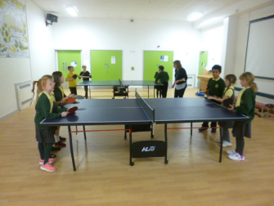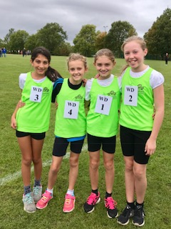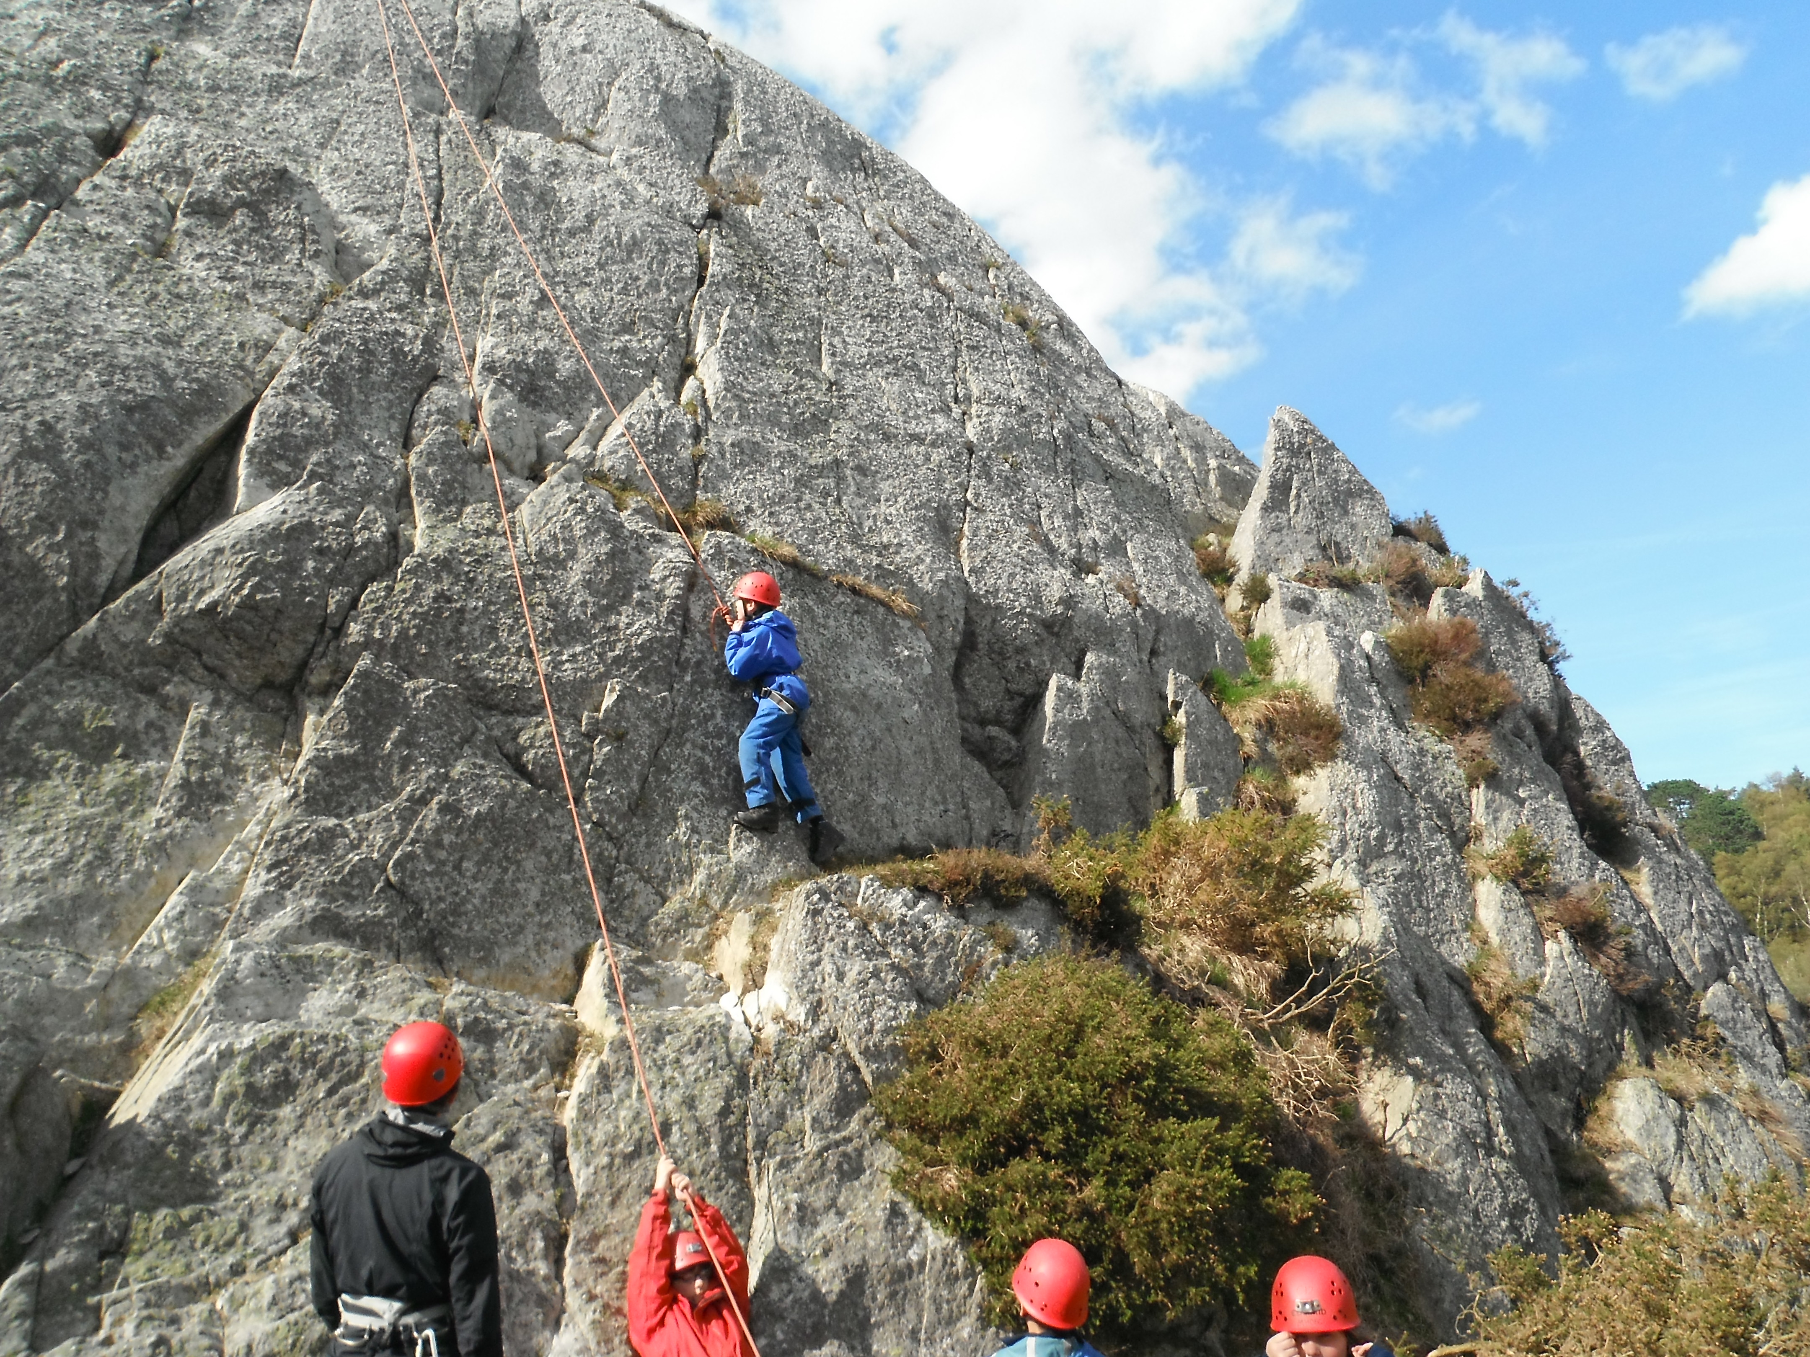
Before and After School Care

OSCAR (Out of School Care and Recreation) provides safe and enjoyable childcare for children from Reception to Year Six. This is an Out-of-School Provision, with recreational activities led by children, managed by adults. We offer a range of activities, indoors and out, based on arts and crafts, games, toys, puzzles and physical activities, which change regularly and are closely supervised by staff, encouraging social play and interaction. We pride ourselves on being well resourced, and we are lucky enough to have our own room, with use of the practical area in Year Three, the small hall and the full range of outside facilities, including the Adventure Playground.

Breakfast Club |  |  | After School Club
7:45am - 8:45am | £3.30* |  | 3:15pm - 4:00pm | £3.30
7:45am - 8:45am | £3.30* |  | 3:15pm - 5:00pm | £6.60 **
7:45am - 8:45am | £3.30* |  | 3:15pm – 5.30pm | £8.30 **
* Breakfast £1.00 extra (served until 8.15 am)  - optional, but needs to be pre-booked |  |  | ** Tea £1.50 extra –  Optional, but needs to be pre-booked

A handbook with further details on OSCAR is available on request. You can contact OSCAR directly by phone on 01926 499452 or email Oscar@welearn365.com

As OSCAR is managed by Woodloes Primary School, it has adopted all relevant school policies which are available on request at the school office.

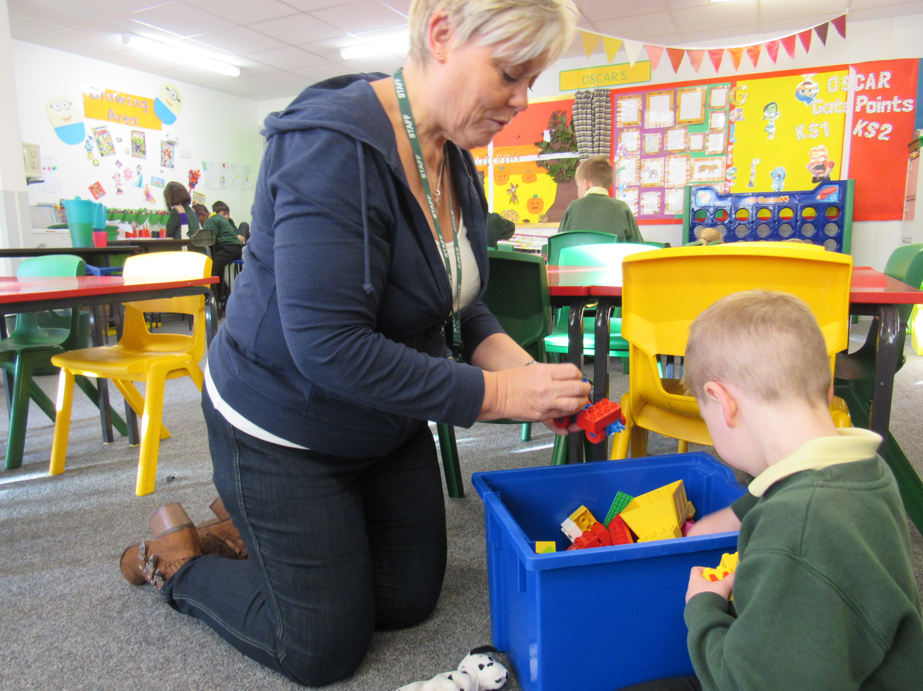

Pre-School Provision

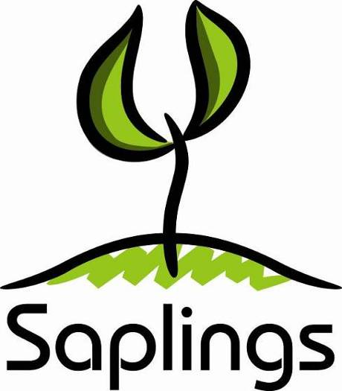
Saplings Pre-School is a wonderfully exciting Pre-School that is situated in and is part of Woodloes Primary School.

We have a fantastic team of Pre-School trained and dedicated practitioners who engage the children in exciting and fun activities to help them learn without even realising!

All staff are qualified to at least Level 3 and the Manager is qualified to Degree level in Childcare.

Saplings Pre-School offers:

15 hours free childcare

30 hours free childcare funding for 3 & 4 year olds (subject to eligibility). Refer to http://www.childcarechoices.gov.uk/

Lunch club 12.00-12.30pm for children attending all day. Sessions need to be pre-booked and pre-paid (£2.00 per session, or £4.61 if a hot dinner required)

Lunch club is optional. Children can be collected for the lunch time session and go home for lunch.

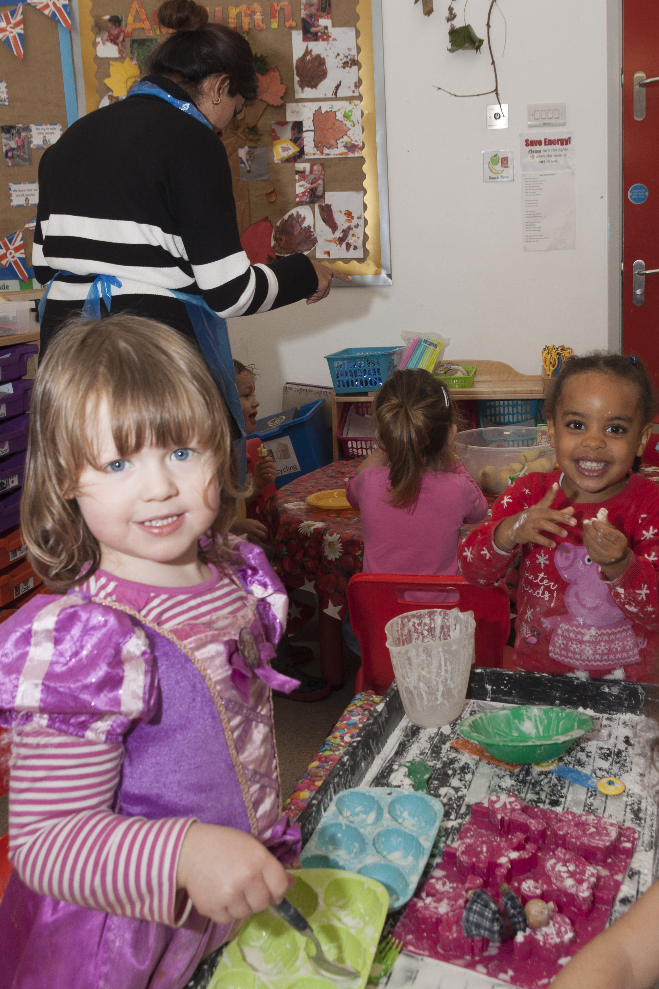
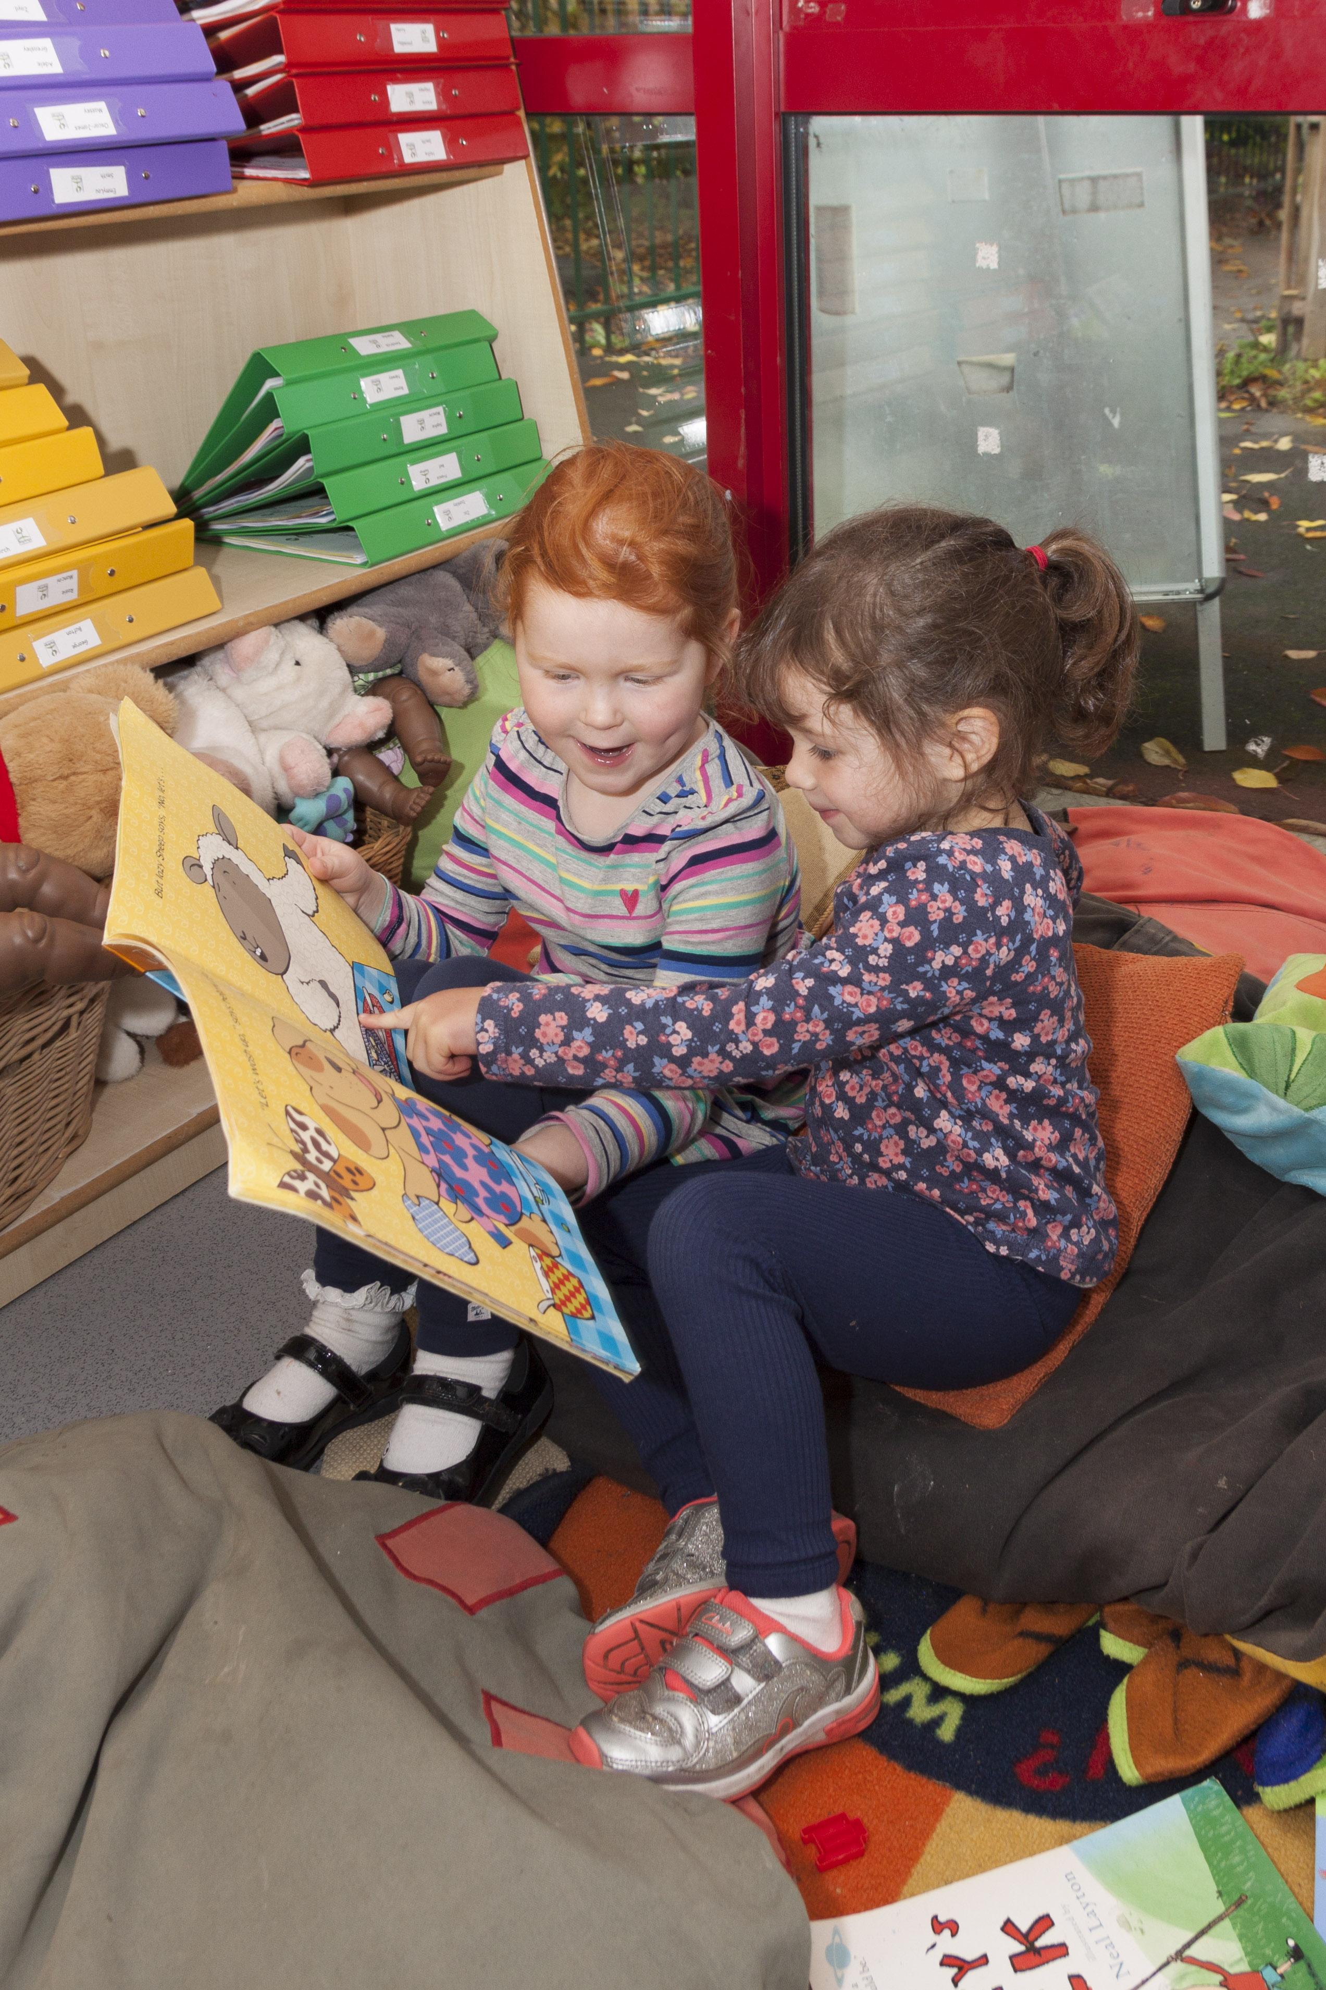

Parental Engagement
Pupils’ progress and development are influenced positively where schools and parents work in partnership. We value the support and interest of our parents; they and the children are equally important elements of the school. We hope that the following factors will help the effectiveness of this partnership:

- A website and virtual learning environment (VLE)
- A parents' handbook (prospectus)
- Curriculum information evenings
- Information booklets e.g. "Helping your child with Reading"
- A weekly newsletter
- Achievement assemblies and class assemblies
- Easy accessibility to staff and senior managers
- Parent notice board
- Regular parent consultation evenings
- Education workshops /talks
- Social events
- Parental involvement in school
- Volunteers
- Friends of Woodloes Primary School (Parent Teacher Association)
- Home school agreement

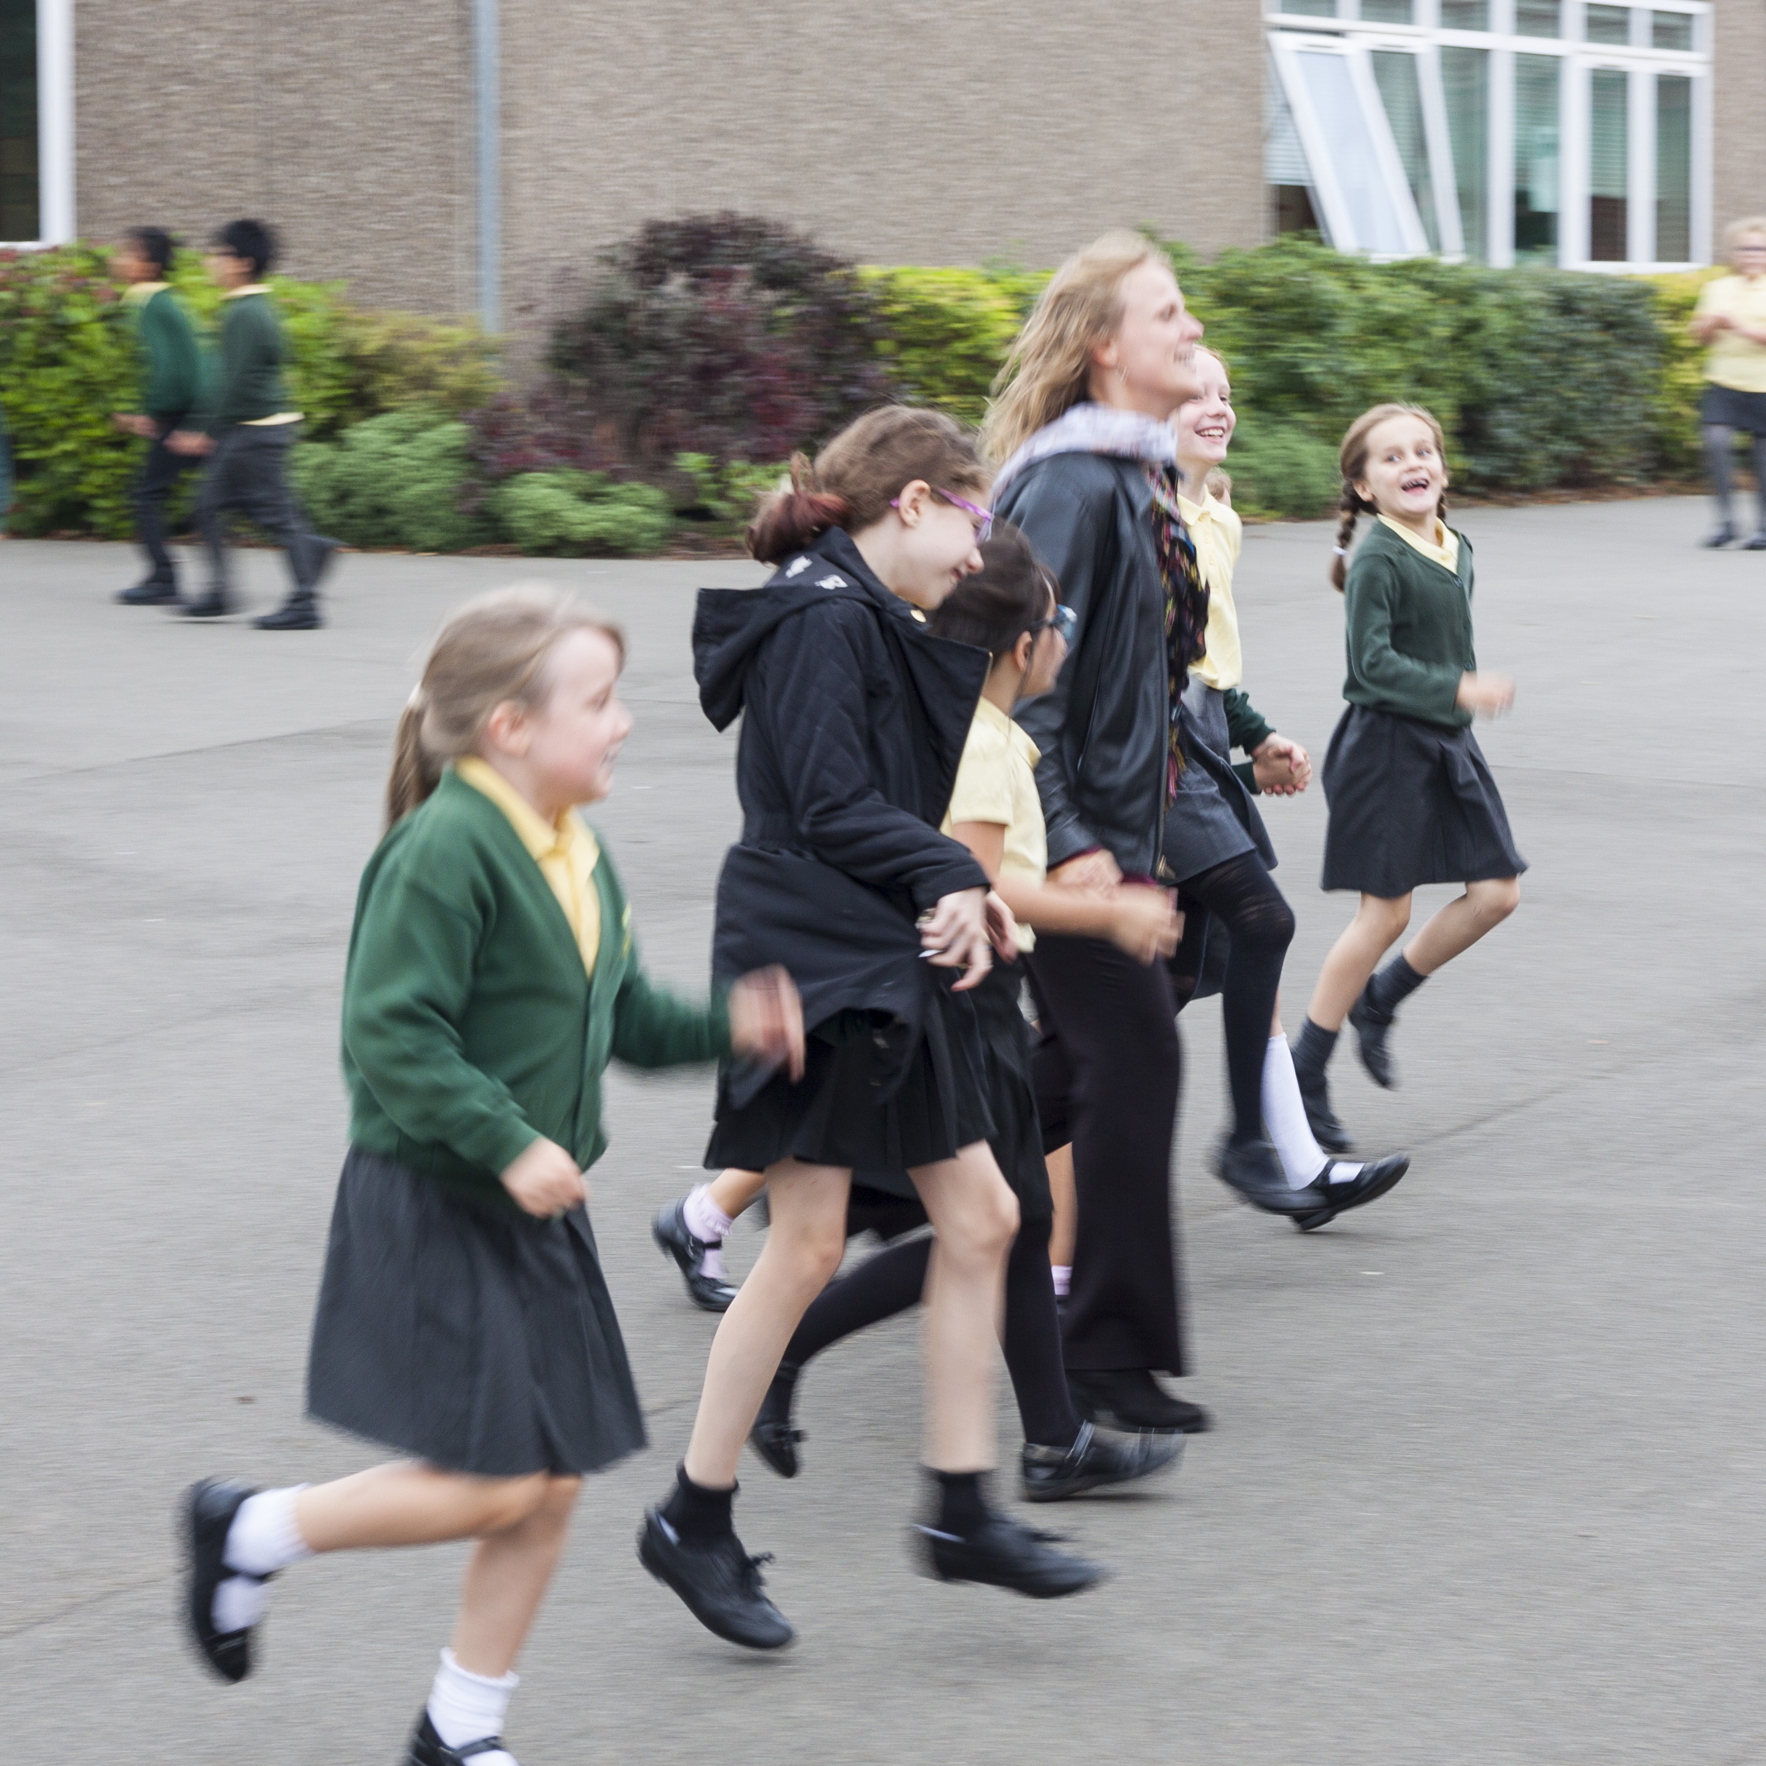
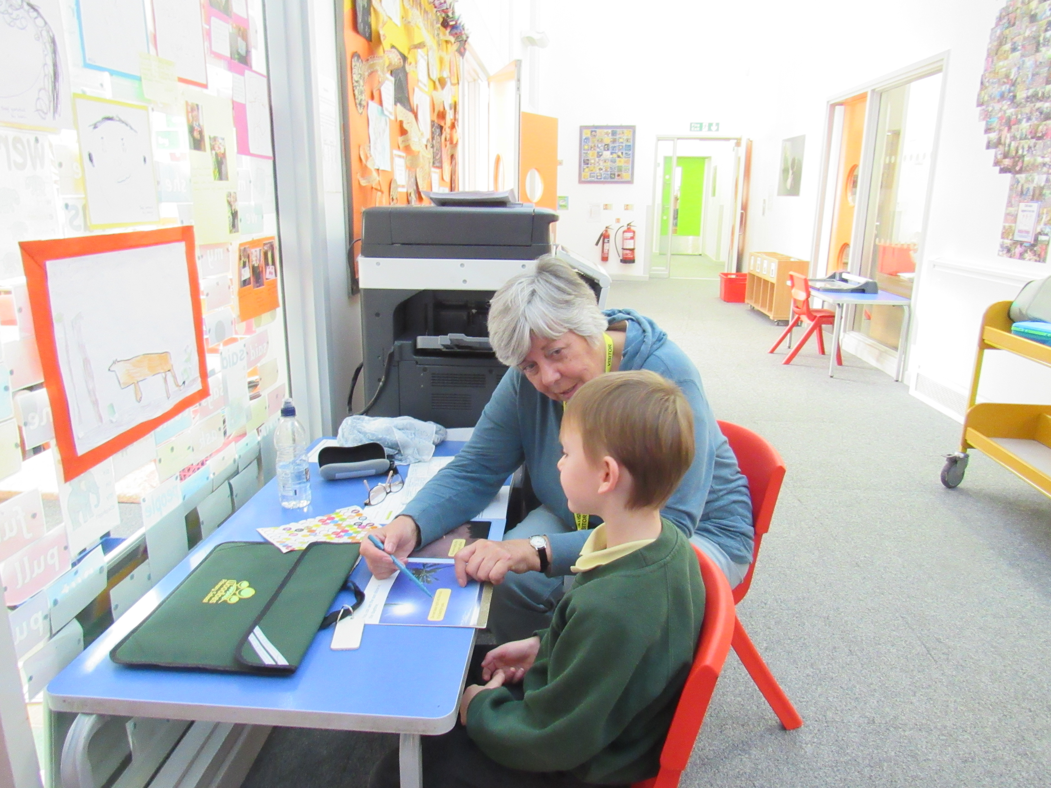

Many parents provide valuable assistance to teachers and children in class and find this a very rewarding and enjoyable experience. Activities include shared reading, cookery, art, technology, maths games, sewing and accompanying children on trips.

If you have a passion for something or an area of expertise that you could share with our children and staff, then please let us know!

As a parent, you will always receive a professional welcome at Woodloes Primary School; we are here to help and offer assistance whenever we can. Should you have any issues or concerns about your child or the school then an appropriate member of staff will be pleased to see you to as soon as possible to offer support.

We find it much better to deal with any problem at the outset rather than let it build up into something more worrying and difficult to handle.

Parent Teacher Association
An active PTA known as Friends of Woodloes Primary School works to provide social, educational and fund-raising activities for the benefit of parents, children and the school. Our intention is to provide the children, staff and parents with an annual schedule of events that bring smiles to faces, raise a bit of money and promote our school to the wider community.

Membership consists of parents/carers, governors, teaching and support staff. We aim to have representation on the committee from every year group.

The committee meets as and when required to organise the diary of events and there is an Annual General Meeting in the Autumn term each year. If members cannot attend meetings they can still offer to help with events and be kept informed via email. Our aim is to share the tasks, helping to make being a committee member an enjoyable and rewarding experience.

If you are interested in contributing and being involved with the Friends of Woodloes Primary School speak to any of the committee or email friendsofwoodloes@live.co.uk

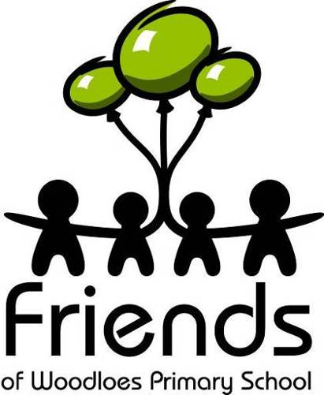

Community Cohesion
We are very keen to develop positive relationships with our local community and work hard to create opportunities to share information and provide support. A wide range of community activity is promoted at school to ensure that our children develop a sense of social responsibility.

Health & Safety

The health and safety of children in the school building, the grounds and online are of paramount importance and, to preserve these, there are certain regulations concerning routine. We also include aspects of health and safety training in our curriculum.

We have a duty to ensure that all children’s health and well being is safeguarded. We discuss with parents any concerns we have regarding their children as soon as they arise. However, there may be very rare occasions when the school has to consult with other agencies before parents are contacted. Should this be necessary parents can be reassured
that any concerns the school has about a child will then be fully discussed with their parents.

A full copy of the H&S policy is available at the school office.

Equality and Diversity
We ensure that our school reflects in a positive way the social, cultural and linguistic diversity of our society. All children have equal access to the curriculum regardless of gender, race or disability. The school is supported by various outside agencies to ensure that all children have the opportunity to experience success and to achieve the highest possible standards.

The Local Governing Body
A local governing body (LGB) is responsible for the strategic management of the school and represents all stakeholders in fulfilling its duties. The LGB represents the Directors of the Community Academies Trust to ensure the school operates to the very highest standards and within all statutory frameworks. Its membership consists of community, parent and staff governors and it provides challenge and support to senior leaders.

School governors commit to giving time and energy to the role. Each governor contributes to the work of the governing body and shares the load bringing their own interests and expertise to this very rewarding role. Governors are asked to take part in half-termly meetings, read and produce documents and to maintain close contacts with the school to verify evidence and confirm standards.

A governing body works closely with its School Leadership Team with a view to promoting high standards of educational achievement. It fulfils its obligations by establishing the strategic framework by:

- Setting aims and objectives with the school.
- Adopting policies for achieving those aims and objectives.
- Setting targets for achieving those aims and objectives.

Our School Governors
Andy Mitchell  Head Teacher | Sue Robinson  Community Governor | Kim Eccleston  Community Governor
Louisa Farino  Chair of Governors | Mitch Reynolds  Community Governor | Sarah Burnard  Teacher Governor
Mick Potter  Vice Chair of Governors | Michael Loizou  Parent Governor | Sian Stevens  Associate -Governor
Adele Stevenson  Clerk to the LGB | Ed McMillen  Parent Governor

If you would like to join or need to contact the governing body for any reason whatsoever, please feel free to contact the Chair of the Governing Body via the school office or the Head Teacher.

2019 – 2020 Term and Holiday Dates

Autumn Term 2019
Teacher Training Day - Monday 2nd September 2019

Term Starts - Tuesday 3rd September 2019
Teacher Training Day – Friday 25th October 2019
Half Term - Monday 28th October to Friday 1st November 2019
Term Ends - Friday 20th December 2019

Spring Term 2020
Teacher Training Day – Monday 6th January 2020

Term Starts – Tuesday 7th January 2020
Half Term - Monday 17th February to Friday 21st February 2020
Term Ends – Friday 3rd April 2020

Teacher Training Day – Monday 20th April 2020

Summer Term 2020
Term Starts – Tuesday 21st April 2020
Bank Holiday – Friday 8th May 2020
Half Term – Monday 25th to Friday 29th May 2020
Teacher Training Day – Friday 19th June 2020
Term Ends - Friday 17th July 2020

Teacher Training Day – Monday 20th July 2020

