Dear Parent/Carer,

Welcome to Maths with Parents.

We are a not-for-profit organisation that works to support effective home learning for primary school children. Your school’s maths subject lead has signed up for free this term so you can be supported to help with your child’s learning while at home.

**What is Maths with Parents?**

Through our online platform, you and your child will watch short videos explaining the topics your teacher chooses, and then play fun games and activities together using items around the home to explore the maths in the real world. The class teacher then gets your feedback and photos so they can see how you are getting on.

**To Sign Up**

1) Visit http://www.mathswithparents.com

2) Click the Enter Site button, then the New Parent button

3) Enter details about you and your child and click Confirm

4) Enter your child’s 6-digit class code (once you have registered, you will not need this again!)

**Class: 1L**

**Class Code: 790482**

(Further guidance on the next page)

**You have Signed Up – what next?**

* Use your password to login (your username is your email address; your password will be emailed to you)
* Watch the introductory video to see how it works
* Then watch the video for the first topic with your child and choose the activity to play first
* After you have played the activity together, leave feedback for the teacher or upload a photo. This is really important, so they know how your child is getting on
* 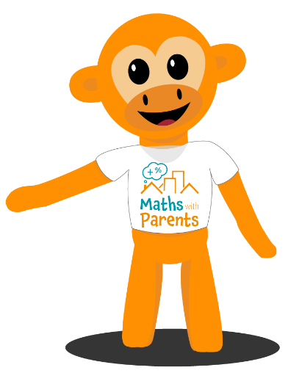Pick an item to dress up your Mathscot!

Every time the class teacher sets a new topic, we will email you to let you know.

We hope you enjoy exploring the topics together!

Best wishes,







[www.mathswithparents.com](http://www.mathswithparents.com)

|  |  |  |
| --- | --- | --- |
| 1 | Click Enter Site, then New Parent button |  |
| 2 | Enter your details, then your child’s name |  |
| 3 | Enter your child’s 6-digit class code.  Once you have used this to register, you will not need it again! |  |
| 4 | Then you will see your login details, so you are ready to get started and enjoy our games and activities at home! | |