Accessing Welearn365 for additional resources such as Microsoft Office and Teams.

Enter the website www.welearn365.com and then in the dropdown menu select Woodloes Community Primary School

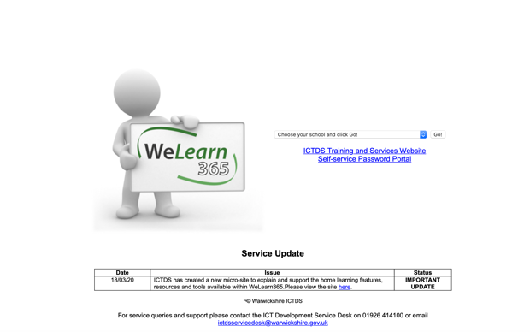

On the next page you will need to enter your Welearn 365 details.

Please note that passwords are case sensitive meaning that you will need a capital letter if you have one in your password.

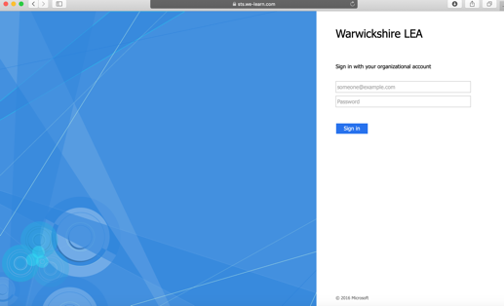

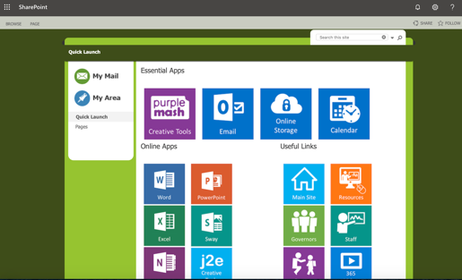
Once logged in - On the next page you should see apps like Purple Mash/ Word/Excel etc.

If you click on ‘My mail’ and then Teams you should be prompted to either download the Teams app or use Teams online.

