Guys Cliffe Animal Walk
This time of year is best for seeing animal dens: because the leaves aren’t covering them up yet and the animals are active.
Only cross the Coventry road with an adult, and don’t disturb the animals with noise or banging. Foxes and badgers and rabbits are mostly nocturnal, so they will be asleep.
1
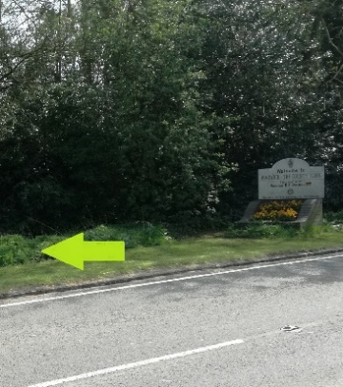
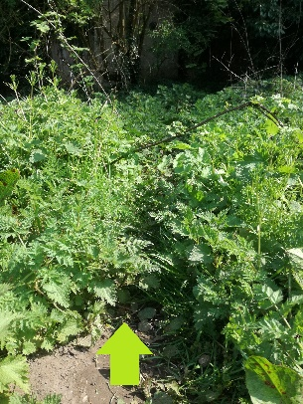
Look for the tiny animal track by the Warwick sign (but only cross the road if you are with an adult). It leads off into the bushes and there are a few feathers lying around. There is a string musky smell: the smell of fox!

2
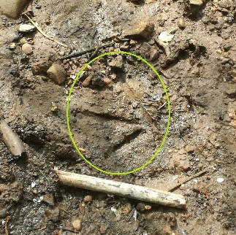
Swan Footprint: Look on the muddy patches on the far bank from the weir for coot and swan footprints.

3
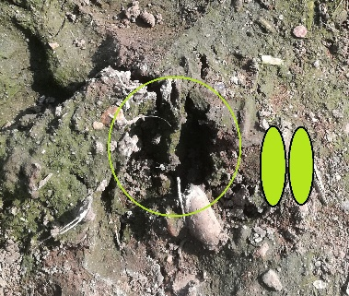
In the dry mud at the start of the footpath across the field there are loads of dog paw prints and tyre prints and one set of roe deer slots (deer footprints are called slots).

4
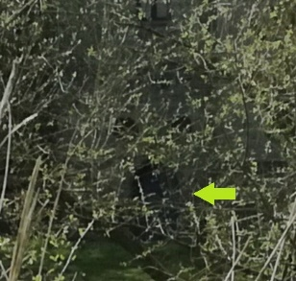
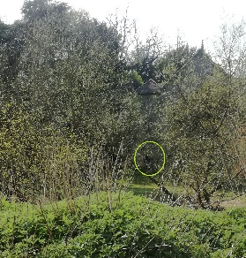
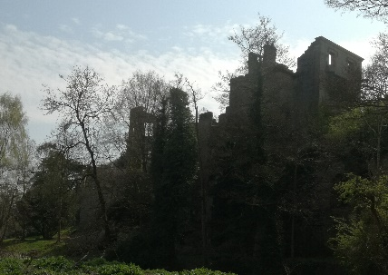
Guys Cliffe ruin and a glimpse of Guy’s cave from the spit of land between the river and the field.

5
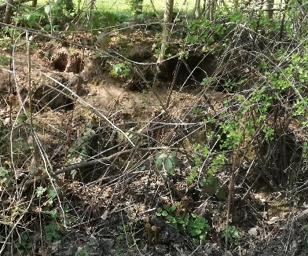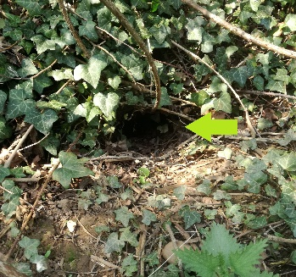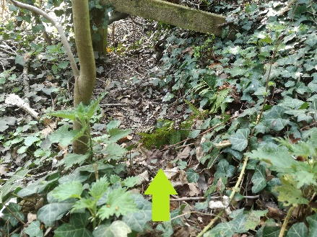
A rabbit warren is easy to see across the ditch and, where the fence ends, one last hole and a rabbit path that goes back to the warren under the hedge.

6
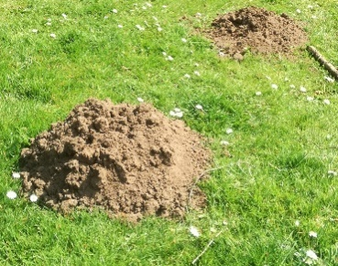
Mole hills in the lawn where the footpath joins the track by the bridge over the A46. You won’t see the mole, they almost never come above ground, but if you watch for long enough you might see more earth being pushed up from underneath.

7
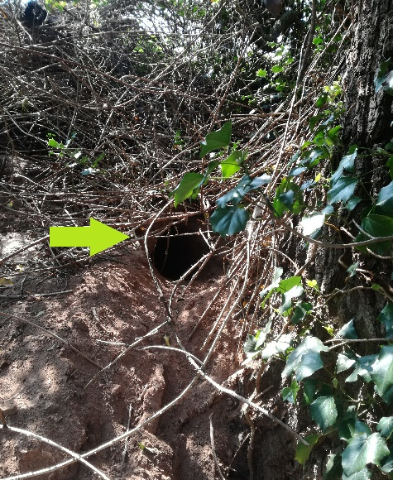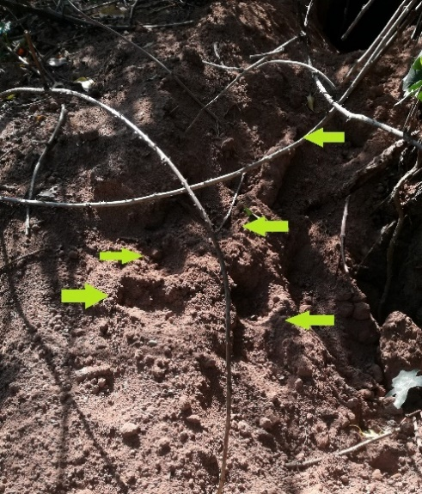
Hidden behind a tree is a badger’s set! There is fresh red earth that the badger has dug out this year and in the fresh earth and you can see where the badger has dug it’s feet in climbing back up to the hole.

If you spot anything for yourselves, take a picture and send it to me!
Admin5207@welearn365.com

