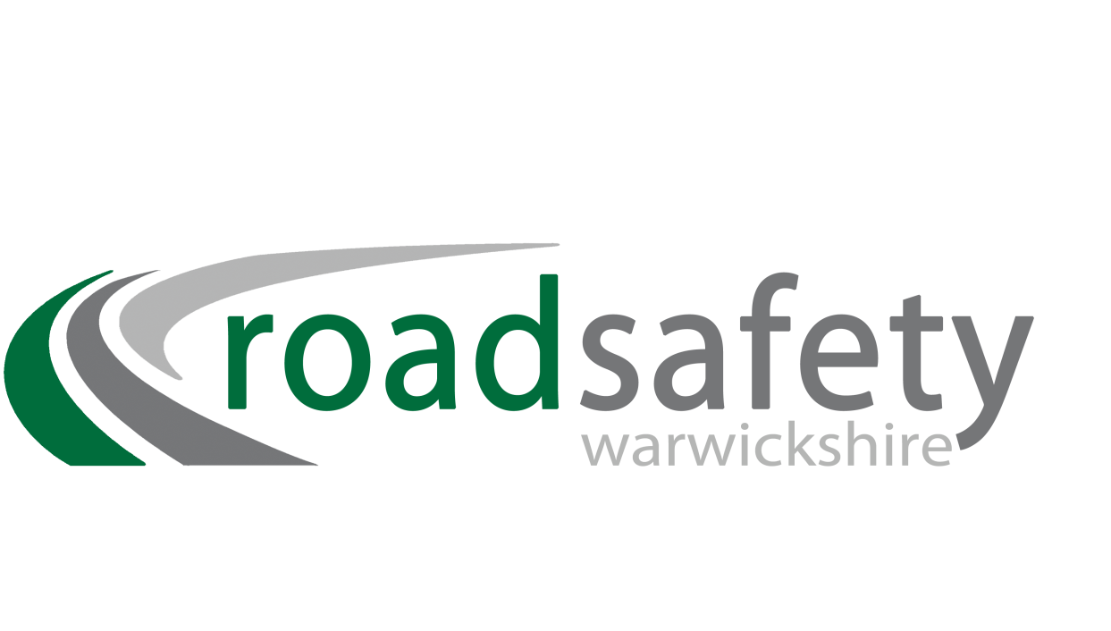

www.warwickshire.gov.uk/schoolcrossingpatrols

Would you or anyone you know like to be an

**School Crossing Patrol for**

**Woodloes Primary School, Warwick**

Join our team now and make a real difference!

Full training and uniform provided

and excellent rates of pay.

Please call 01926 412661 or email scp@warwickshire.gov.uk for further details.

**VACANCY**