**MFL**

**Computing**

**Creating a mammoth fact file**

Developing word processing skills

Internet research and communication

**Science**

**Rocks and soils**

Compare and group together different kinds of rocks

Relate the properties of rocks to their formation

Describe how fossils are formed

**Theme:**

**Stone Age Boy**

**Year 3**

**1st half Autumn Term 2018**

**MFL**

**Art & Design**

**What do cave paintings teach us about the Stone Age?**

Explore cave-art and what was being communicated through it

What can we infer about life in the Stone Age through cave-art?

Develop techniques, including control and use of different materials

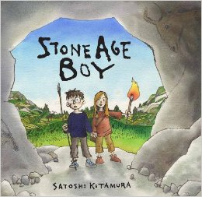

**Maths**

Using the 6 part maths lesson we will be learning about:

Number and place value

Counting and comparing numbers

Visualising and constructing

**Music**

**Upbeat** -Following a program of study through Warwickshire Music Service

**RE**

Taught during PPA each week

**Physical Education**

**Gymnastics**

Develop flexibility, strength, technique, control and balance

**English**

**Narrative writing** – creating Stone Age stories based on the class text (Stone Age Boy)

**Writing poetry** – Stone Age Bone Age and Caveman Dan

**Writing instructions** – How to wash a Woolly Mammoth

**Report writing** – Stone Age clothing, food and housing

**History**

**Who were the early Britons?**

Gain an understanding of life in early Britain including the Stone, Bronze and Iron Age

* Stone Age life
* Skara Brae
* Bronze Age to Iron Age