**History**

**Space travel now and in the past**

**Neil Armstrong and the moon landings**

**Tim Peake**

**Mars exploration**

**The moon landings**

**To find out about Neil Armstrong**

**Space**

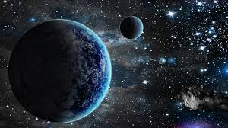

**Science**

**Finding out about the sun**

**Sources of light and reflections and shadows**

**Making a simple circuit to light a bulb**

**Name common materials and their properties**

**R.E and PSHE**

**Shining Lights**

**Getting on and falling out**

**P.E**

**Body shapes – curling and stretching**

**To link two actions together to make a sequence**

**Literacy**

**Write a report on a crash landing**

**Drama**

**Alien poems**

**Make an information book**

**Write a space adventure story**

**Christmas letters, lists and recipes**

**DT**

**Shadows and shadow puppets**

**Exploring wheeled toys**

**To make, test and evaluate a moon buggy**

**The Arts**

**The long and the short of it (exploring duration)**

**Exploring colour and texture through a variety of art pieces**

**Mathematics**

**Money**

**Addition and subtraction**

**Doubling and halving**

**Alien problem solving**

**Odd and even numbers**

**Measures including time**