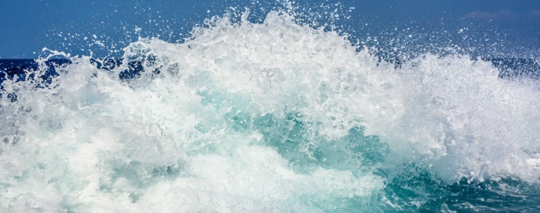

**Topic**

* The 7 continents and 5 oceans
* Countries and characteristics of the UK
* The great barrier reef.

**Computing**

* Animate stories: use ‘2 create a super story’ to draw and retell the Snail and the Whale story picture book.
* Positional language using Textease Turtle

**Science**

* Animal needs and survival
* Animal and human offspring
* Exercise and healthy eating
* Hygiene
* Experiment: hat shape is a bubble?

Maths

* Time – 5 minute intervals and sequencing
* Subtraction with borrowing
* Odd and even numbers
* Money- adding coins and giving change, find different combinations of same amount
* Addition, subtraction, multiplication, division, fraction of a number
* Fraction of a shape and line of symmetry
* 2, 3, 5, 10X table
* Units of measure: length, weight, capacity and reading scales
* Estimate on a blank number line
* 2-step problems/ reasoning skills

**TRIP**

**Birmingham Sealife Centre**

**Thursday 8th March**

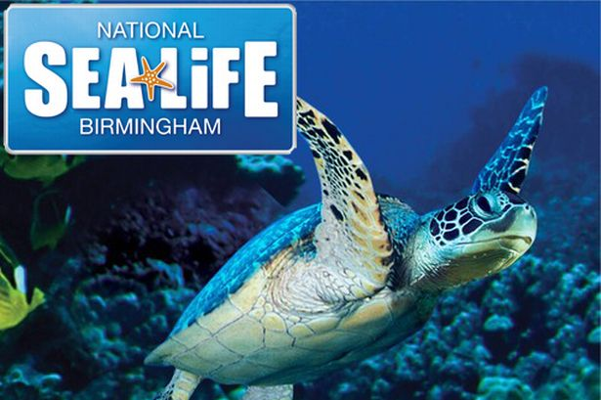

**PE**

* Onside coaching
* Forest School

**Art and Design**

* Under water sea creature crafts
* Ocean collage
* Monet water colour
* Rainbow fish clay modelling
* Sock octopus craft

**Phonics**

* Suffixes: ness, ment, ful, less, er, est
* Compound words
* Le, al, el, il word endings.
* All sound
* Words ending in tion
* Hard/ soft c

**English**

* The Snail and the Whale (Julia Donaldson)
* The Sound Collector poem
* Descriptive writing, character and setting description, narrative
* Non-chronological report
* Recount of the trip to the Sealife Centre
* Letter writing and postcard
* Instructions
* Book review

**GP&S**

* Exam style questions – sentence types, use of punctuation, conjunctions, suffixes, word classes and singular/ plural words.

*Due to a short Spring B term and End of KS1 tests taking place in Summer A term, this topic will be covered over the two half terms alongside teaching for the assessments.*

**PSHE/ RE**

* Islam
* Rules and responsibilities

**splash attack**

**Year 2**

**Spring B & Summer A**