29th January 2019

Dear Parents/Carers
Book Week 11th – 15th February
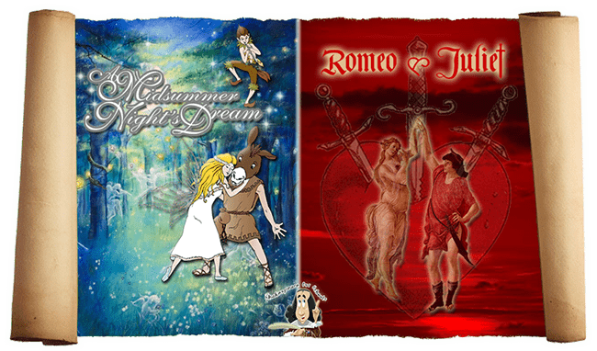
Our annual book week is fast approaching and it is yet another opportunity for us to celebrate our love of reading with the children. We have a fun-filled week planned which will begin with an exciting Shakespeare double bill of Midsummer Night’s Dream and Romeo and Juliet. Comedy and tragedy in a day.
The SPLAT theatre company will perform the two Shakespeare shows and lead workshops on Tuesday 12th February. The cast mix modern language and original text to make the stories fun and clear.
On Wednesday 13th, we will be running our book sharing café with the Friends of Woodloes in OSCAR and the small hall. You are invited to come into the café and share a book with your child. Each year group will be given a time slot to visit the book fair and café (see below). If you attend, your child will be able to join you and share a book with you whilst enjoying a drink and a cake. Please donate cakes for the café on Tuesday 12th or Wednesday morning. Money raised from this event will go to Friends for future resources and activities for all of the children.
9.30-10.00  Saplings | 10.-10.30  Reception | 10.30-11:00  Year 3 | 11.00-11.30  Year 4 | 11.30-12.00  Year 1 | 1.15 – 1:45  Year 6 | 1:45-2:15  Year 2 | 2:15 – 2:45  Year 5

Throughout the week, we’ll have our Scholastic Book Fair. It will be open Monday to Thursday in the small hall from 3.15 until 4.00pm. Please come and support the book fair to generate commission for us to buy new books in school. If you are available to help run the fair, please let the school office know. Any help would be greatly appreciated.

Finally, the week will end with a poetry slam when each class will perform a poem or Shakespeare extract of their choice. The children are invited to come to school dressed as a character on the Friday (15th February). The themes for each class are detailed below:
Year group | Theme
Saplings | Any story character
Reception | Any story character
Year 1 | Any story character
Year 2 | Dragons, knights and princesses or any story character
Year 3 | Romans, Celts or a story character
Year 4 | Characters linked to A Midsummer Night’s Dream or any story character
Year 5 | Characters linked to Romeo and Juliet, travel or any story character
Year 6 | Marvellous Monarchs or any story character

As you can see, the children have got a busy book week ahead of them and there are lots of opportunities for you to get involved as well. We hope that the week will inspire the children to read for pleasure and enable us to raise money to provide fantastic books for them to read.
We look forward to seeing you at the book fair.
Yours sincerely,
Tina Lambert
English Leader

