

Deansway, Woodloes Park, Warwick Telephone 01926 497491
Admin5207@welearn365.com www.woodloes.com

OPEN DAY
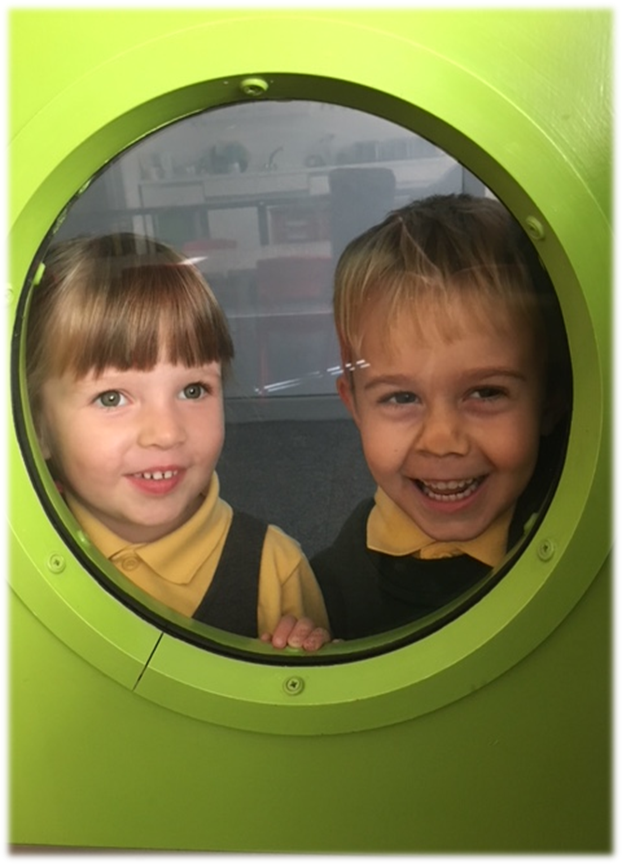

If you are looking for the right school for your child for Reception 2020, we would like to invite you to come and look at our fantastic facilities:-

Thursday 4th July 9.15am-10.30am
Wednesday 2nd October 9.15am-10.30am
Tuesday 19th November 1.15pm-2.30pm

Come and see Woodloes Primary School in action!

There will be a Presentation by our Head Teacher, followed by a visit to our Reception classes. You will be able to talk to the Reception teachers, watch the children engaged in activities and let them tell you about their work. You will also have the opportunity to be shown around the school by our current Year 6 pupils. Bring your child with you – they are welcome to join in!


“Children in the early years receive an excellent start to school life. High quality teaching and excellent pastoral care enable children to make exceptional progress in all areas of learning.”
Ofsted March 2019

