Friday 17th November 2017
Dear Parents / Carers
Reception and Saplings Christmas Production
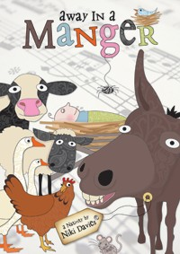
Children in Reception and Saplings will be performing their Christmas Production ‘Away in a Manger’ on Friday 15th December and rehearsals will soon be under way.

Your child ___________________________is going to be __________________________.

We would like to ask for your support by providing a costume for your child in a named carrier bag by Friday 1st December. You can start bringing in your costumes from Monday 27th November.

Some of the Reception children have speaking parts. If your child has words to learn, they are attached to this letter. Please can you help your child to learn their words at home before rehearsals begin on Thursday 30th November.

If you have any questions or concerns about this years production, please do not hesitate to speak to your child’s teacher.

Many thanks.
Mrs Stevens and Miss Lyons

